Eli Ordonez Capstone Project Technical Report

This document serves as a technical guide to my capstone project. While I have tried my best to explain my processes, do refer to my Jupyter Notebook for further details.

Table of Contents

Section 1: Problem, Goals and Audiences 2

1.1 Problem 2

1.2 Goals 2

1.3 Audience 3

Section 2: Data Handling and Overall Approach 3

2.1 Datasets Used 4

2.1.1 “Top Spotify Songs in 73 Countries” Dataset 4

2.1.2 “Daily Historical Japan (Tokyo) Weather”Dataset from Open-Meteo 6

2.1.3 “Realtime Weather Readings across Singapore” & “Sunshine Duration- Monthly Mean Daily Duration” Datasets from Data.gov.sg 7

2.2 Data Retrieval & Cleaning 9

2.2.1 Spotify Data (Japan and Singapore) 9

2.2.2 Open-Meteo Data (Tokyo Weather Dataset) 12

2.2.3 Data.gov.sg Data (Singapore Weather Dataset) 13

Section 3: Analysis & Hierarchical Clustering 17

3.1 Exploratory Data Analysis (EDA) on Weather Data 17

3.1.1 EDA on Tokyo Weather Dataset 17

3.1.2 EDA on Singapore Weather Dataset 19

3.2 Exploratory Data Analysis (EDA) and Hierarchical Clustering on Spotify Data 21

3.2.1 EDA and Hierarchical Clustering on Japan Spotify Data 22

3.2.2 EDA and Hierarchical Clustering on Singapore Spotify Data 25

Section 4: Modelling Preparations 28

4.1 Forming the Final Modelling Dataset (Japan) 28

4.1.1 Merging Daily Cluster Proportionality Data with Daily Weather Data 28

4.1.2 Adding Season as a Variable to the Dataset 28

4.1.3 Final Data Checks 29

4.2 Forming the Final Modelling Dataset (Singapore) 30

4.2.1 Merging Daily Cluster Proportionality Data with Daily Weather Data 30

4.2.2 Final Data Checks 30

Section 5: Modelling 31

5.1 Modelling on the Japan Dataset 31

5.1.1 Train/Test Split 31

5.1.2 XGBoost Regression 32

5.1.3 Optimised Weather Data (XGBoost + Targetted X Variables) 33

5.1.4 CatBoost Regression 35

5.2 Modelling on the Singapore Dataset 37

5.2.1 Train/Test Split 37

5.2.2 XGBoost Regression 38

5.2.3 Optimised Weather Data (XGBoost + Targetted X Variables) 39

5.2.4 CatBoost Regression 41

5.3 Results Summary 43

Section 6: Conclusions & Recommendations 43

6.1 Conclusions 43

6.2 Limitations of Project 44

6.2.1 Inadequate Data 44

6.2.2 Data Limitations 45

6.2.3 Assumptions on Music Listening Habits 46

6.3 Recommendations 46

# Section 1: Problem, Goals and Audiences

### 1.1 Problem

As smartphone penetration – and therefore digital consumption – increases in East and Southeast Asian economies, the music streaming industries in these regions are as competitive as ever.

Spotify, a stalwart of the music streaming industry, is now facing pressure to maintain its market dominance as new regional players begin gaining substantial followings across East and Southeast Asia. China’s Tencent Music Entertainment, for instance, experienced a 13.4% year-on-year increase in subscribers across its various music streaming platforms in 2024 Q4[1], and is showing no signs of slowing down.

To retain users – and even acquire new ones – Spotify must find new and novel ways to encourage user activity and engagement, even if in the short term.

### 1.2 Goals

This project aims to boost Spotify’s user engagement and sales through the development of a model that can curate a dynamic playlist based on the day’s weather conditions.

This promotional strategy is meant to encourage user retention and create enough marketing buzz to potentially acquire new users.

To establish the clearest relationship between music listening habits and weather conditions, I wanted to focus on a geography which featured a wide seasonal variation throughout the year. I wanted to focus on East Asia considering its growing prominence as a global economic hub and as a player in the global music streaming industry. I have chosen to work with Spotify and weather data from Japan due to my interest in the country and curiosity about its cultural consumption.

If successful, this project would be able to deliver a usable model that Spotify Japan can use to curate a weather-based dynamic playlist.

As an addendum, I also carried out my modelling processes using Spotify and weather data from Singapore to explore the feasibility of establishing a weather-based dynamic playlist within the local context, especially since Singapore is noted for having minimal seasonal variation outside of sunny or rainy weather. However, this additional analysis was purely meant as exploration. Most of this project’s analysis will focus on Japan’s data, and modelling on Singapore’s data was conducted in a similar fashion as that for Japan’s.

### 1.3 Audience

This project is targeted towards Spotify’s Head of Marketing for Asia, Jean-Paul Jeffrey. As of 29 May, 2025, he oversees marketing initiatives across both Southeast and East Asia[2].

# Section 2: Data Handling and Overall Approach

For this project, multiple layers of aggregation were conducted as my general approach involved the following:

For Japan

* Separately sourcing the following data:
  + Japan’s daily Top 50 songs on Spotify between 18 October 2023 and 30 April 2025
  + Daily weather data from a specific prefecture during the same time period.
* Cleaning weather data to ensure the following:
  + No Duplicates
  + No Invalid values
  + No Null Values
  + Datatypes were accurate
* Cleaning Spotify data to ensure the following:
  + No Duplicates
  + No Invalid values
  + No Null Values
  + Datatypes were accurate
* Assigning distinct songs from Spotify data to clusters based on musical characteristics
* Calculating the percentage of songs from each cluster in the Top 50 playlist for each day
* Merging this aggregated Spotify data playlist with the daily weather data
* Constructing a model based on the merged dataset

For Singapore

* Calling the appropriate APIs on Data.gov.sg’s “Realtime Weather Readings Across Singapore” dataset to obtain the following weather data:
  + Per-minute temperature readings
  + 5-minute rainfall readings
  + Per-minute relative humidity readings
  + Per-minute wind speed readings
* Aggregating the data such that I get the following:
  + Min/Max/Mean Temperature
  + Mean/Total Rainfall
  + Min/Max/Mean Relative Humidity
  + Min/Max/Mean Wind Speed
* Merging the resultant dataset with data from Data.gov.sg’s Monthly Mean Daily Duration dataset, to ensure the weather data accounts for sunlight received
* All steps described for Japan’s data but applied to Singapore’s data.

### 2.1 Datasets Used

#### 2.1.1 “Top Spotify Songs in 73 Countries” Dataset

* This dataset documents the Top 50 songs for over 70 countries and is updated daily.
* Japan and Singapore are among the countries that are tracked in this dataset
* The dataset covers the period between 18 October 2023 and 30 April 2025, a 561-day duration.
* According to Kaggle user Asaniczka (who compiled and updates the dataset), the data was obtained by “querying the Spotify API for the top 50 songs for each country every day”.
* Most importantly, the dataset lends itself to clustering well due to the availability of columns that rate a song’s characteristics on a scale of 0 to 1.

**Data Dictionary (Columns used for clustering highlighted in orange)**

|  |  |  |  |
| --- | --- | --- | --- |
| **Column Name** | **Type** | **Description** | **Reason for Exclusion** |
| Spotify_id | str | The unique identifier for the song in the Spotify database. | Does not describe the song’s musical qualities |
| Name | str | The title of the song. |  |
| Artists | str | The name(s) of the artist(s) associated with the song. Do split(', ') to convert to a list |  |
| Daily_rank | int | The daily rank of the song in the top 50 list. | Does not describe the song’s musical qualities |
| Daily_movement | int | The change in rankings compared to the previous day. | Does not describe the song’s musical qualities |
| Weekly_movement | int | The change in rankings compared to the previous week. | Does not describe the song’s musical qualities |
| Country | str | The ISO code of the country of the Top 50 Playlist. If Null, then the playlist if 'Global Top 50'. | Does not describe the song’s musical qualities |
| Snapshot_date | str | The date on which the data was collected from the Spotify API. | I wanted to cluster distinct songs from the dataset, regardless of when they were included in the Top 50. |
| Popularity | int | A measure of the song's current popularity on Spotify. | Does not describe the song’s musical qualities |
| Is_explicit | boolean | Indicates whether the song contains explicit lyrics. | Does not describe the song’s musical qualities |
| Duration_ms | int | The duration of the song in milliseconds. | Does not describe the song’s musical qualities |
| Album_name | str | The title of the album the song belongs to. | Does not describe the song’s musical qualities |
| Album_release_date | str | The release date of the album the song belongs to. | Does not describe the song’s musical qualities |
| Danceability | float | A measure of how suitable the song is for dancing based on various musical elements. |  |
| Energy | float | A measure of the intensity and activity level of the song. |  |
| Key | int | The key of the song. | It may not be important in understanding a song's mood and feel. Both upbeat and mellow songs can be written in any key. |
| Loudness | float | The overall loudness of the song in decibels. |  |
| Mode | int | Indicates whether the song is in a major or minor key. |  |
| Speechiness | float | A measure of the presence of spoken words in the song. |  |
| Acousticness | float | A measure of the acoustic quality of the song. |  |
| Instrumentalness | float | A measure of the likelihood that the song does not contain vocals. |  |
| Liveness | float | A measure of the presence of a live audience in the recording. | I feel that this column describes the quality of the recording more than the song itself (e.g whether it is upbeat and fast vs. sad and slow). |
| Valence | float | A measure of the musical positiveness conveyed by the song. |  |
| Tempo | float | The tempo of the song in beats per minute. |  |
| Time_signature | int | The estimated overall time signature of the song. | May not be important in understanding a song's mood and feel as both upbeat and mellow songs can be written in various time signatures. |

#### 2.1.2 “Daily Historical Japan (Tokyo) Weather”Dataset from Open-Meteo

* This dataset compiles daily summaries of Tokyo’s weather between 18 October 2023 and 30 April 2025, a 561-day duration.
* This dataset was downloadable as a CSV file.
* According to Open-Meteo’s website, the platform “brings together cutting-edge local (1 km resolution) and global (11 km) weather models sourced from renowned national weather services” including Japan Meteorological Agency.
* All columns were considered in the model as any of the weather measurements could impact music listening patterns.

**Data Dictionary (All columns used for modelling)**

|  |  |  |
| --- | --- | --- |
| **Column Name** | **Type** | **Description** |
| Time | Str | Date of record |
| Temperature_2m_max (°C) | float | Maximum daily air temperature at 2 meters above ground |
| Temperature_2m_min (°C) | float | Minimum daily air temperature at 2 meters above ground |
| Temperature_2m_mean (°C) | Float | Mean daily air temperature at 2 meters above ground |
| Rain_sum (mm) | Float | Sum of daily rain |
| Snowfall_sum (cm) | Float | Sum of daily snowfall |
| Precipitation_sum (mm) | Float | Sum of daily precipitation (including rain, showers and snowfall) |
| Relative_humidity_2m_max (%) | Int | Maximum relative humidity at 2 meters above ground |
| Relative_humidity_2m_min (%) | Int | Minimum relative humidity at 2 meters above ground |
| Relative_humidity_2m_mean (%) | Int | Mean relative humidity at 2 meters above ground |
| Wind_speed_10m_max (km/h) | Float | Maximum wind speed and gusts on a day |
| Wind_speed_10m_min (km/h) | Float | Minimum wind speed and gusts on a day |
| Wind_speed_10m_mean (km/h) | Float | Mean wind speed and gusts on a day |
| Daylight_duration (s) | Float | Number of seconds of daylight per day |
| Sunrise (iso8601) | Str | Sun rise times |
| Sunset (iso8601) | Str | Sun set times |

#### 2.1.3 “Realtime Weather Readings across Singapore” & “Sunshine Duration- Monthly Mean Daily Duration” Datasets from Data.gov.sg

“Realtime Weather Readings across Singapore”

* This dataset enables the retrieval of real-time recordings of weather parameters via API calls, including the following (which were included in my weather dataset for Singapore):
  + Per-minute temperature readings across all weather stations in Singapore
  + 5-minute rainfall readings across all weather stations in Singapore
  + Per-minute relative humidity readings across all weather stations in Singapore
  + Per-minute wind speed readings across all weather stations in Singapore
* The API calls created 4 big datasets containing all measurements between 18 October 2023 and 30 April 2025. Each dataset was summarised to provide the following:
  + Min, max and mean temperature per day
  + Mean and total rainfall per day
  + Min, max and mean relative humidity per day
  + Min, max and mean wind speed per day
* When calculating the mean for the relevant weather parameters, all null values were ignored in the Python processing.
* These measurements were then concatenated into a single, final dataset representing Singapore’s weather for each day for the 561-day period.

“Sunshine Duration – Monthly Mean Daily Duration”

* This dataset is a compilation of the monthly mean of daily sunshine duration in hours in Singapore.
* This dataset was downloadable as a CSV file.
* Some disclaimers must be noted:
  + Only one measurement is available per month, making this column function differently from the “daylight_duration” column in the Tokyo weather dataset.
  + The data was only collected from Changi Climate station, rather than from all weather stations
* This column was included as it is the only dataset from a government source that documented daylight duration in Singapore.
* It was also merged with the final dataset representing Singapore’s weather described above, with the monthly mean daily duration measurement repeated for every day in a month.

**Data Dictionary (Columns used for modelling in orange)**

|  |  |  |  |
| --- | --- | --- | --- |
| **Column Name** | **Type** | **Description** | **Reason for Exclusion** |
| Date | Datetime | Date of measurement | Irrelevant as this dataset was later joined with aggregated music data from Singapore, which already has a date column |
| Min_temp | Float | Minimum temperature recorded across all weather stations and timestamps |  |
| Max_temp | Float | Maximum temperature recorded across all weather stations and timestamps |  |
| Mean_temp | Float | Mean temperature recorded across all weather stations and timestamps |  |
| Mean_rainfall | Float | Mean rainfall recorded across all weather stations |  |
| Total_rainfall | Float | Total rainfall recorded throughout the day |  |
| Max_rh | Float | Maximum relative humidity recorded across all weather stations and timestamps |  |
| Min_rh | Float | Minimum relative humidity recorded across all weather stations and timestamps |  |
| Mean_rh | Float | Mean relative humidity recorded across all weather stations and timestamps |  |
| Max_ws | Float | Maximum wind speed recorded across all weather stations and timestamps |  |
| Min_ws | Float | Minimum wind speed recorded across all weather stations and timestamps |  |
| Mean_ws | Float | Mean wind speed recorded across all weather stations and timestamps |  |
| Month | Datetime | Date at the start of each month | Was only meant to facilitate a join with “monthly_mean_sunshine_hours” data |
| Mean_sunshine_hours | Float | Monthly mean daily sunshine hours recorded from Changi Weather Station |  |

### 2.2 Data Retrieval & Cleaning

#### 2.2.1 Spotify Data (Japan and Singapore)

* **Duplicate Rows**
  + Japan Dataset (30 April 2025): 3 songs were found to have a duplicate row with the same artist and musical measurements, but with the song title in romanized Japanese rather than in hiragana script. Their indexes were removed from the data.

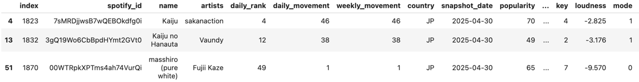

* + Singapore Dataset: No duplicate rows were identified when accounting *only* for musical measurement data.
    - I decided to check for duplicates this way as this rules out the possibility of missing duplicates because of slightly different names (i.e. different language) or artists.
* **Handling Null Values**
  + Japan Dataset
    - There were 14 rows which missed data under ‘album_name’.
    - All 14 rows turned out to belong to data on the same song. A quick search reveals that NAYEON's 'ABCD' was released on an EP called “Na” on 14 June 2024.
    - After checking that the “album_release_date” for all 14 rows is “14 June 2024”, I imputed the album title “Na” to these 14 rows.

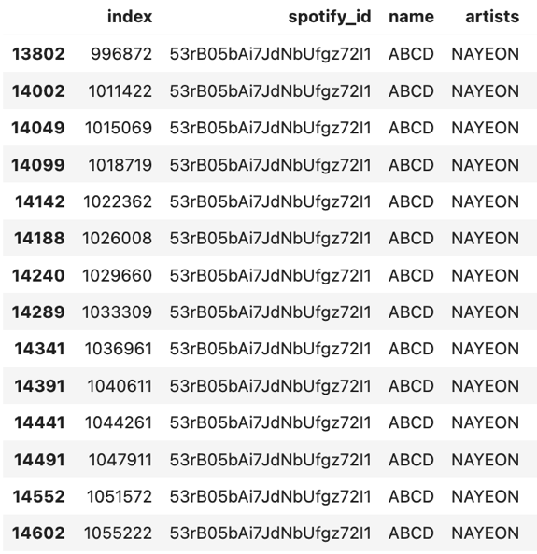

* + Singapore Dataset
    - There were 30 rows which missed data under ‘album_name’.
    - Like Japan’s dataset, all 30 rows belonged to the same song, “ABCD” by “NAYEON”.
    - I imputed to these rows the song’s album title, leaving no other null values in the dataset.
* **Handling Inaccurate Data Types**
  + Japan Dataset
    - 'snapshot_date' converted to datetime
    - 'album_release_date' converted to datetime
    - 'is_explicit' converted from Boolean to int type, so values would read as 0 or 1.
  + Singapore Dataset
    - 'snapshot_date' converted to datetime
    - 'album_release_date' converted to datetime
    - 'is_explicit' converted from Boolean to int type, so values would read as 0 or 1.
* **Final Dataset Form**
  + Japan Dataset
    - No null values
    - No duplicate rows
    - Data types corrected where necessary
    - Final shape: 27,052 rows, 26 columns

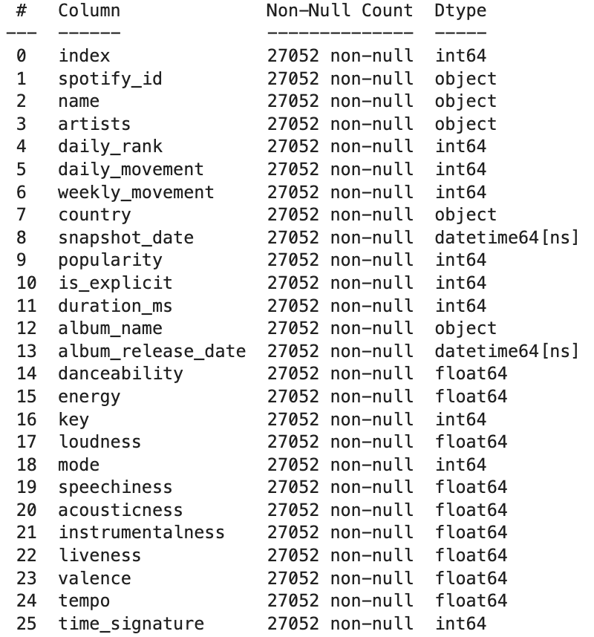

* + Singapore Dataset
    - No null values
    - No duplicate rows
    - Data types corrected where necessary
    - Final shape: 27,011 rows, 26 columns

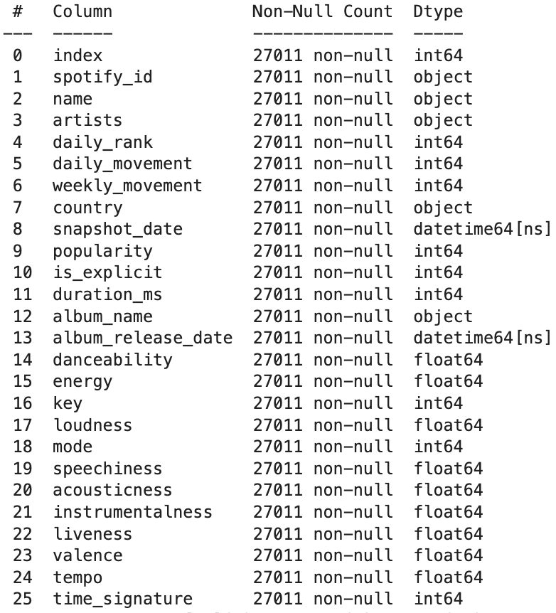

* **Missing Days from Dataset**
  + The data source stated that “data may be missing / incomplete from 2024-11-27 to 2024-12-09 due to Spotify API changes”, so I wanted to check if there were any missing dates from the Japan or Singapore datasets.
  + Japan & Singapore Datasets
    - 20 days are missing:
      * 2024-03-15
      * 2024-03-17
      * 2024-11-28
      * 2024-11-29
      * 2024-11-30
      * 2024-12-01
      * 2024-12-02
      * 2024-12-03
      * 2024-12-04
      * 2024-12-05
      * 2024-12-07
      * 2024-12-08
      * 2024-04-22
      * 2024-04-23
      * 2024-04-24
      * 2024-04-25
      * 2024-04-26
      * 2024-04-27
      * 2024-04-28
      * 2024-04-29
    - Singapore’s dataset was missing one more day: 2024-04-22
  + Ultimately, I decided not to do anything about this as I can simply inner merge with the weather data to avoid creating null values in the merged dataset.

#### 2.2.2 Open-Meteo Data (Tokyo Weather Dataset)

* **Duplicate Rows**
  + There were no duplicated rows.

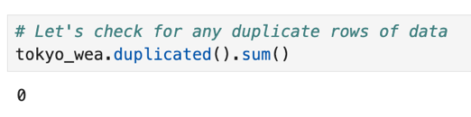

* **Handling Null Values**
  + There were no null values.

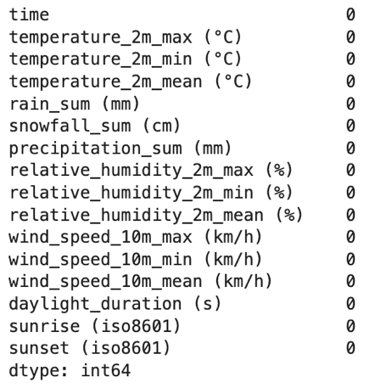

* **Handling Inaccurate Data Types**
  + ‘time’ converted to datetime
  + ‘sunrise (iso8601)’ converted to datetime
  + ‘sunset (iso8601)’ converted to datetime
* **Final Dataset Form**
  + No null values
  + No duplicate rows
  + Data types corrected where necessary
  + Final shape: 561 rows, 16 columns
    - This dataset was saved as a CSV file as backup

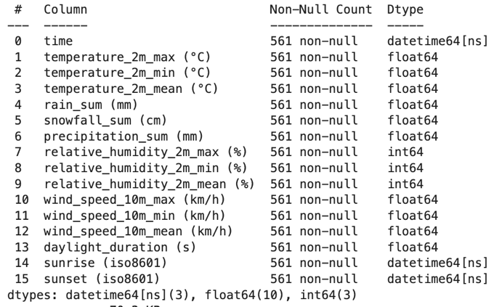

#### 2.2.3 Data.gov.sg Data (Singapore Weather Dataset)

For this section, I will explain my data cleaning slightly differently, as unlike the previous datasets, data was retrieved through API calls.

I will begin by explaining how I retrieved the data to explain how the final combined Singapore weather dataset was retrieved.

**Data Retrieval**

* **NOTE:** While I retrieved 4 raw data sets (one each for temperature, rainfall, relative humidity and wind speed),I will only go through one iteration of my retrieval process as they were executed in an identical fashion.
  1. **I will use my retrieval process for the “temperature” dataset as an example.** If anything about this process was different for the retrieval for the other datasets, I will highlight them.

**Step 1: Obtaining raw data (all readings from all weather stations included in the database on a minute-to-minute basis)**

* Idefined a function which
  1. Defines parameters, gets data from the URL and assigns the JSON of the data to a variable
  2. Gets only the necessary data from the JSON (the data I need is in a list called 'readings', which itself is in a dictionary called 'data')
  3. Initialises a list (data_list) and fills it with dictionaries consisting of "timestamp", "stationId" and "value"
  4. Cycles through every page of the data per day by updating the paginationToken after each call
  5. Repeats this process for the 561-day period between 18 October 2023 and 30 April 2025.
  6. Provides a 2-second pause between calls

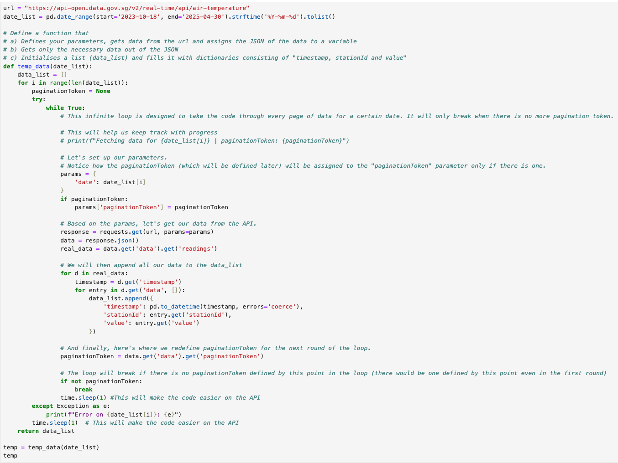

**Step 2: Converting the “data_list” to a dataframe (DF)**

* I defined a function which
  1. Converts the data_list to a DF
  2. Pivots this DF such that all weather stations are columns, and each index is a timestamp. Each value is a temperature reading under a specific weather station
  3. I also inserted a new column, ‘date’, which takes only the date from the timestamp, which is also the index (this serves to facilitate the next step)

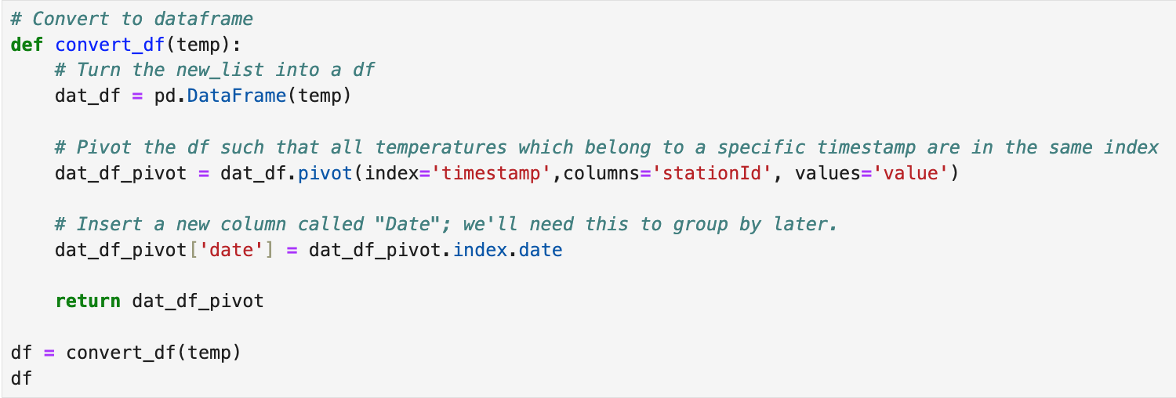

The “temp” DF has 804,250 rows, consisting of every timestamp captured in the data throughout the whole period from the Spotify data. Here is a sample of how it looks like now:

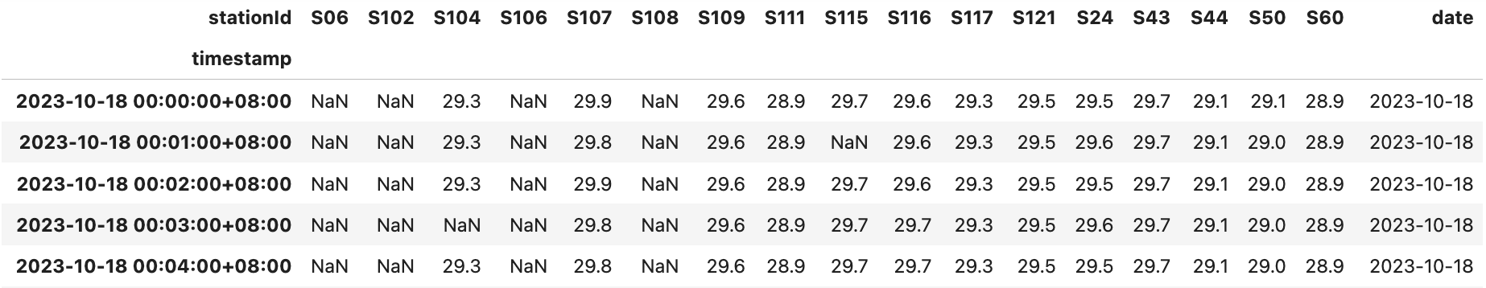

**Step 3: Summarising the DF by only taking the max, min and mean temperatures per day**

* I defined a function which
  1. Groups all readings by the ‘date’ column
  2. From each day’s readings, the function will take the
     + **Min. Temperature**: Takes the minimum per column first, then takes the minimum across all columns’ minimum values.
     + **Max. Temperature**: Takes the maximum per column first, then takes the minimum across all columns’ maximum values.
     + **Mean Temperature**: Stacks all of the day’s readings and takes the mean of all readings
       - **Note**: Doing so will ignore all “null” values, so the presence of null values does not affect the mean.

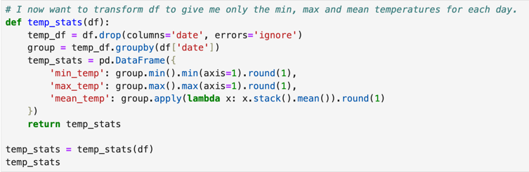

Here is what the final, summarized dataset for temperature looks like:

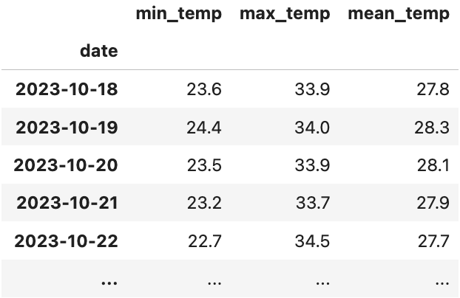

**Note for “mean rainfall” calculation:** For rainfall data, this step was executed differently from temperature, relative humidity and wind speed. This is because:

* Temperature, relative humidity and wind speed are weather parameters which never cease (i.e. there can never be a moment where there is no temperature, relative humidity or movement of air)
* Rainfall is a measure that can have distinct periods of absence and presence
  + A day in Singapore can be sunny in the morning but rainy in the afternoon

If we calculated mean rainfall by dividing the day’s total rainfall by the total number of readings taken that day across all weather stations, the number would not be very meaningful because of all the ‘0’ readings captured throughout the day.

* If on a single day, there was a sudden, heavy downpour in only one region of Singapore for only 30 minutes in the afternoon, that day’s “mean” rainfall would read as a very small number because of all the ‘0’ readings recorded for most of the day. This small number fails to capture the magnitude of the afternoon downpour meaningfully.

To account for the different nature of rainfall as a weather measurement than the other parameters, **“mean rainfall” was calculated by taking the total rainfall collected per day and dividing it by the number of weather stations in the data.**

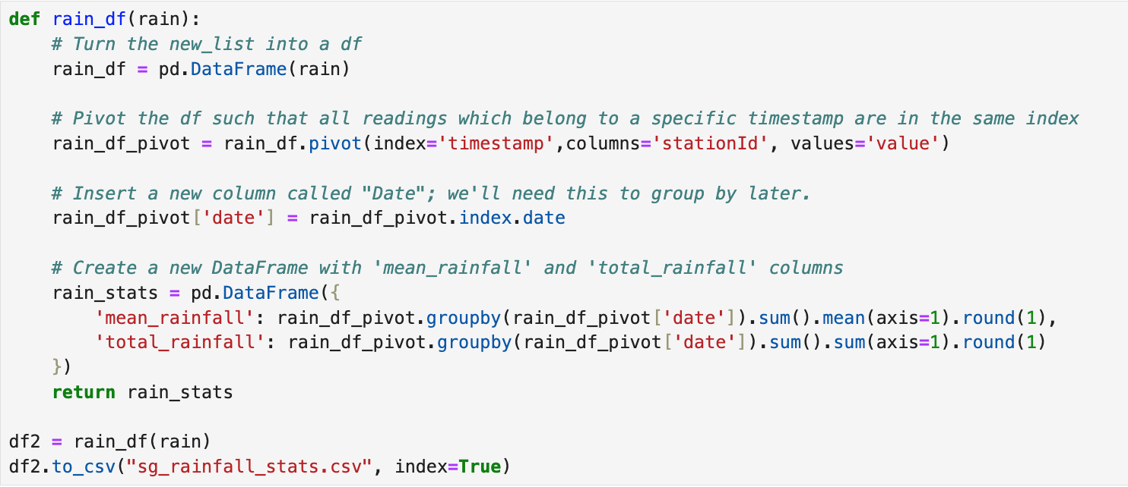

**Final Dataframe Construction**

* I simply merged all 4 dataframes on their respective ‘date’ columns.
* Later, when I found the “Sunshine Duration – Monthly Mean Daily Duration” dataset, I created a temporary column called ‘month’ in the merged dataframe to facilitate merging the monthly mean daily sunlight duration as a column.
  + **Note: For modelling, the “month” column would NOT be included due to its redundancy.**
* After merging the monthly mean daily sunlight duration data, the final dataframe looks like this: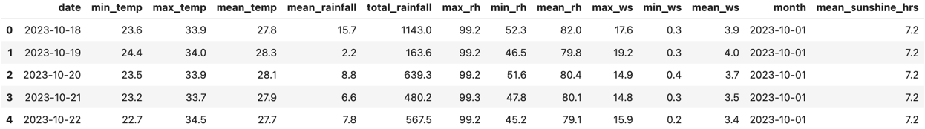
* **Checking for Null Values**
  + There are no null values in the dataset.

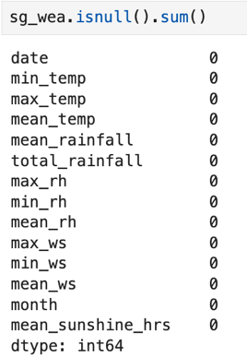

* **Checking for Duplicates**
  + There are no duplicates in the dataset

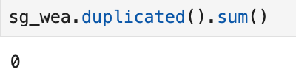

* **Correcting inaccurate datatypes**
  + ‘Date’ was converted to datetime format

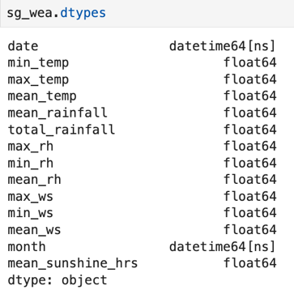

* Final Shape: 561 rows, 14 columns
  + This file was saved as a CSV file as backup

At this stage, I have 4 datasets:

1. Tokyo Weather Dataset
2. Japan Spotify Dataset
3. Singapore Weather Dataset
4. Singapore Spotify Dataset

I will proceed to conduct Exploratory Data Analysis on them.

# Section 3: Analysis & Hierarchical Clustering

### 3.1 Exploratory Data Analysis (EDA) on Weather Data

In this section, I will highlight the most salient findings I’ve uncovered from the weather datasets. I will cover EDA on the Spotify datasets in the following

#### 3.1.1 EDA on Tokyo Weather Dataset

* Temperature is lowest in Jan and highest in Jul/Aug

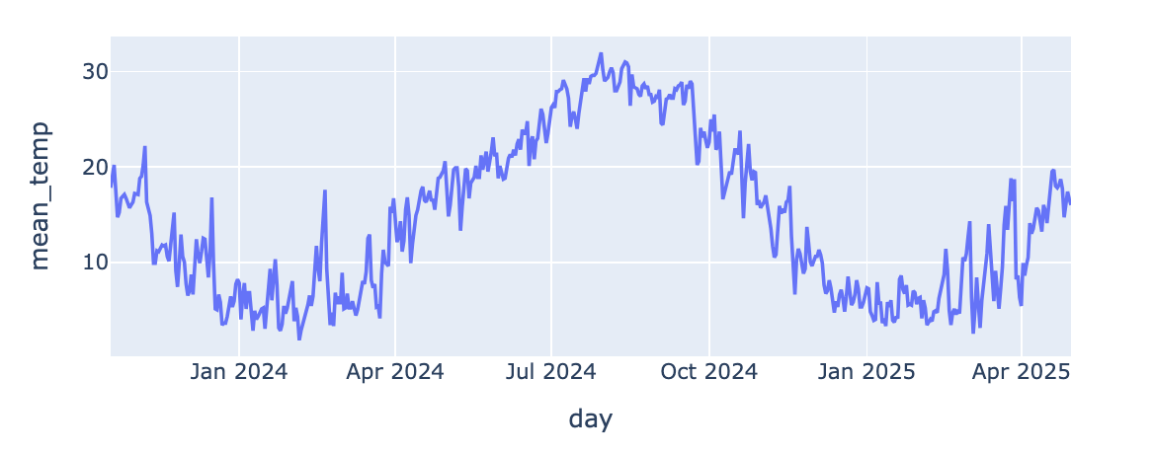

**(Fig. 1)**

* While it is initially difficult to see a general trend for daily precipitation (Fig. 2), monthly precipitation sees a peak in early summer (June), and a low in Winter (Nov-Feb) (Fig. 3).

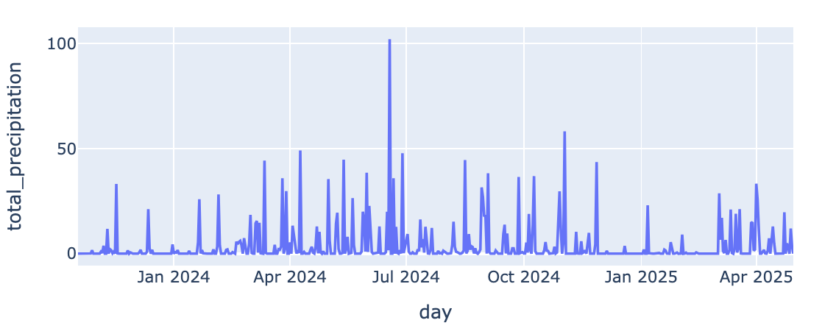

**(Fig. 2)**

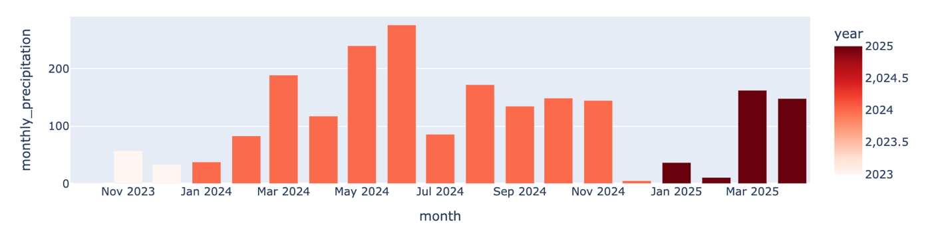

**(Fig. 3)**

* There is a very clear correlation between sunlight duration and time of year

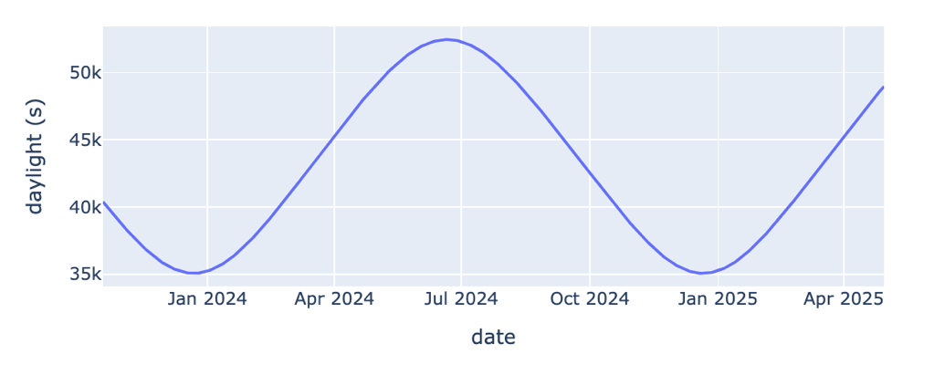

**(Fig. 4)**

* There was no clear observable pattern in mean relative humidity (Fig. 5) or mean wind speed (Fig. 6) throughout the period.

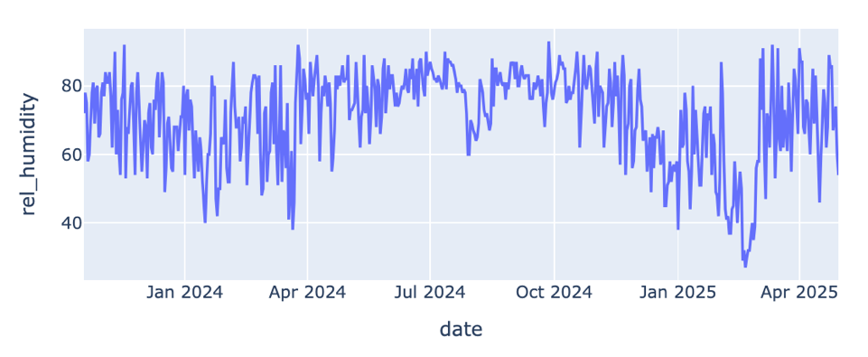

**(Fig. 5)**

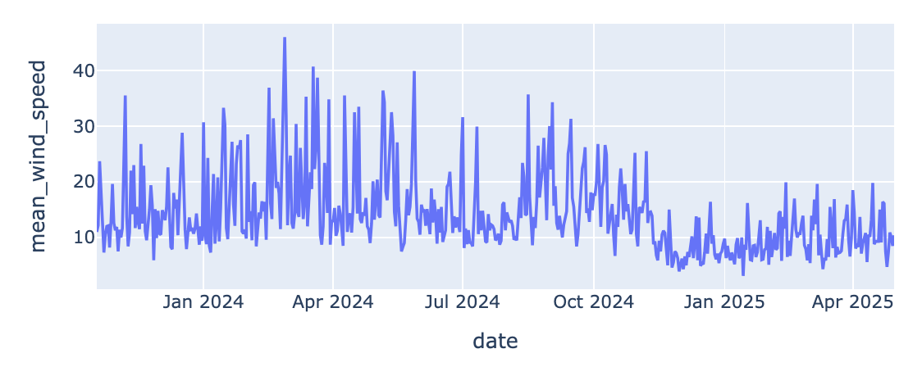

**(Fig. 6)**

Generally, the weather metrics with the most pronounced general trends over time are:

* **Temperature**
* **Sunlight Duration**
* **Precipitation**

This information may be useful for model optimization later on.

#### 3.1.2 EDA on Singapore Weather Dataset

* While temperature drops in Dec/Jan, they lie within the 28-30 degree range for most of the year.
  + In comparison, Tokyo’s temperature has a wider range of between below 5 degrees to above 30 degrees.

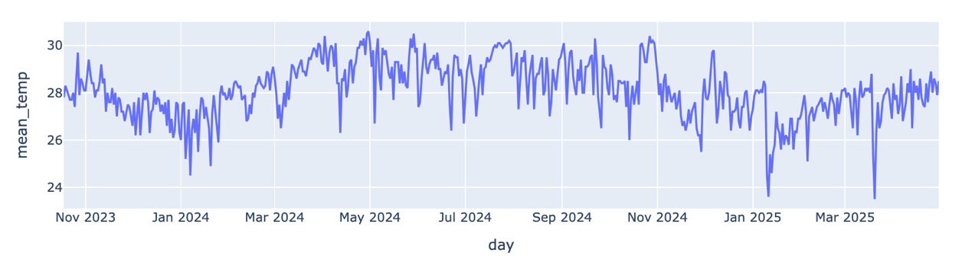

**(Fig. 7)**

* It is difficult to see a general trend for daily precipitation (Fig. 8), and besides reaching a high in January, monthly precipitation is generally quite erratic throughout the year (Fig. 9).
  + While I could consider leaving this out of the model, I will leave this measure in because rainfall is such an integral part of Singapore’s weather.
  + Also note that Singapore’s monthly rainfall reaches into the 20,000mm range. In comparison, Tokyo’s monthly rainfall is consistently below 500mm.

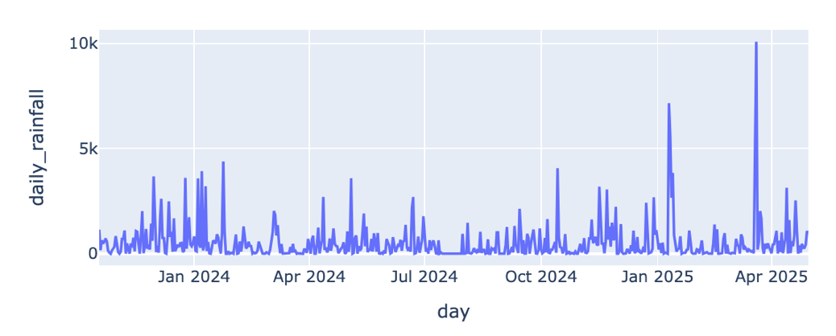

**(Fig. 8)**

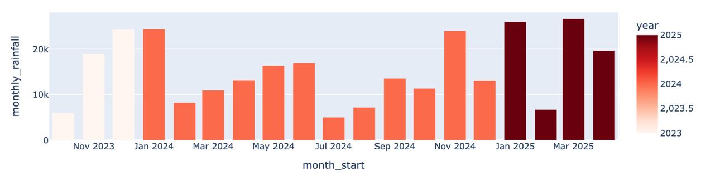

**(Fig. 9)**

* Relative humidity spikes in January. Interestingly, relative humidity seems to mirror monthly rainfall patterns (Fig. 10).

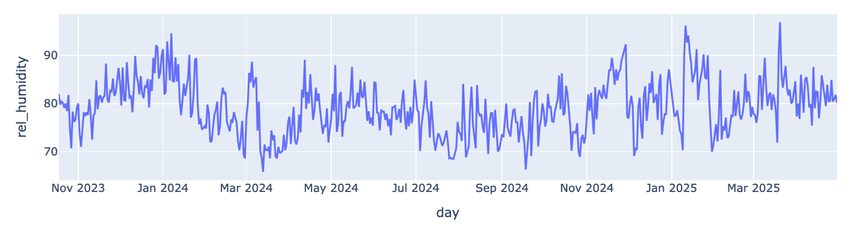

**(Fig. 10)**

* Wind speeds are higher in the beginning of the year (Jan-March) and in the middle of the year (July), and reach lows in Apr/May and Oct/Nov (Fig. 11).

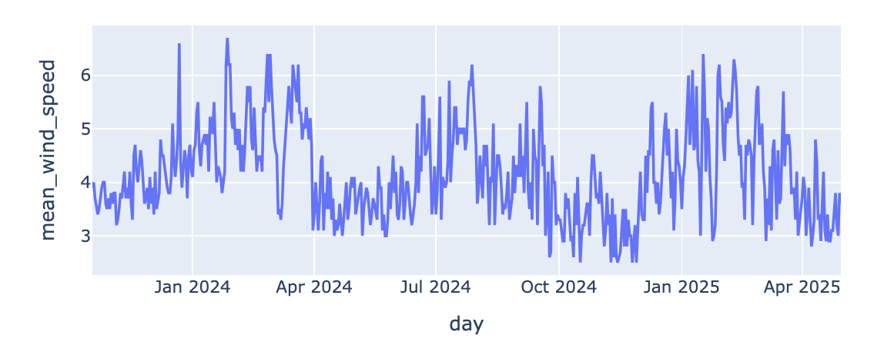

**(Fig. 11)**

* Unlike Tokyo’s data, Singapore’s sunlight duration appears to be quite erratic throughout the year, besides being lowest at the start of the year (Fig. 12).
  + I later found out that monthly mean daily sunshine hours can be affected by cloud cover, haze and rain. Because I am unsure if the Tokyo weather dataset accounts for these factors, I will drop this column if necessary.

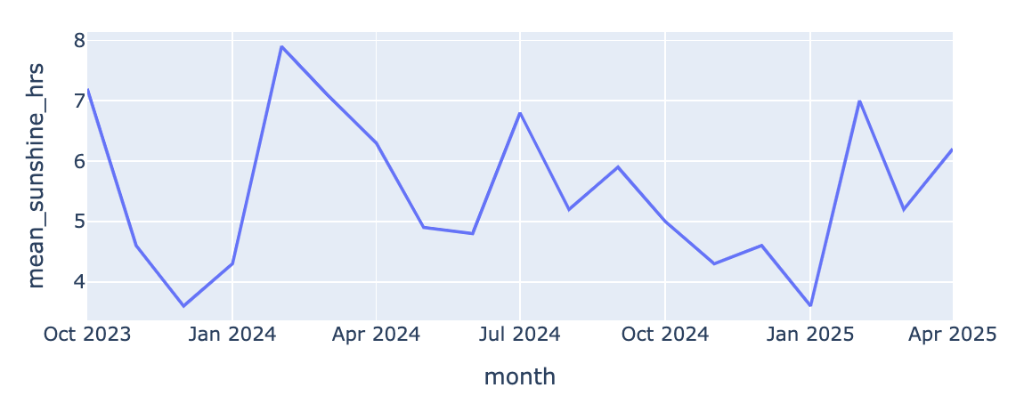

**(Fig. 12)**

Generally, the weather metrics with the most pronounced general trends over time are:

* **Relative Humidity**
* **Temperature**
* **Wind Speed**
* **Rainfall (Included because rainfall makes up much of Singapore’s weather conditions)**

This information may be useful for model optimization later on.

### 3.2 Exploratory Data Analysis (EDA) and Hierarchical Clustering on Spotify Data

At this stage, I will go through my hierarchical clustering process on the Spotify datasets.

I prepared both the Japan and Singapore Spotify datasets for clustering similarly. Generally, I wanted to cluster the songs purely based on their mood and feel, apart from their popularity as popularity can change over time.

**Step 1: Creating a Clustering Dataframe**

To facilitate clustering by the “mood and feel” of the songs, I filtered the dataset to only include the song name (‘name’), artist name (‘artists’), and the following columns:

|  |  |  |
| --- | --- | --- |
| **Column Name** | **Description** | **Reason for Inclusion** |
| Danceability | A measure of how suitable the song is for dancing based on various musical elements. | I found this to be a measure of how upbeat a song is, contributing to mood and feel |
| Energy | A measure of the intensity and activity level of the song. | I found this to be a measure of how energetic a song is, contributing to mood and feel |
| Loudness | The overall loudness of the song in decibels. | I found this to be tied to energy, as more energetic songs are generally louder than less energetic ones |
| Mode | Indicates whether the song is in a major or minor key. | Songs in major keys is generally more emotionally upbeat than songs in minor keys |
| Speechiness | A measure of the presence of spoken words in the song. | I felt that this measure can account for rapped lyrics rather than sung ones. Given the higher energy levels associated with rap music, the presence rapped vocals can add to a song’s general energy level |
| Acoustiness | A measure of the acoustic quality of the song. | Music that uses more acoustic instrumentation generally tends to be less energetic than electronic or rock-adjacent styles |
| Instrumentalness | A measure of the likelihood that the song does not contain vocals. | I foresee that music with higher instrumentalness scores can go in either of two directions: more dance-oriented (less lyrics allows for more of the dance beat) or more somber/gentle. |
| Valence | A measure of the musical positiveness conveyed by the song. | This straightforwardly measures the musical positivity of the song. However, I am unsure if it analyses lyrical content or musical mood. |
| Tempo | The tempo of the song in beats per minute. | A song’s mood and feel can change dramatically based on how fast or slow it is. |

**Lastly, I dropped all duplicate rows so I only get the distinct songs included in each dataset, with each index representing a distinct song.**

#### 3.2.1 EDA and Hierarchical Clustering on Japan Spotify Data

* Clustering dataframe shape: 247 rows, 11 columns

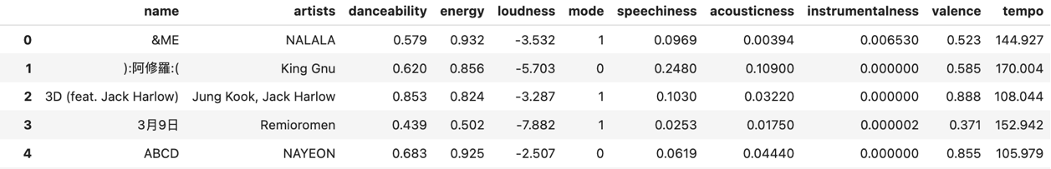

**(Fig. 13)**

* The dataframe shows us that throughout the period between 18 October 2023 and 30 April 2025, Japan’s daily Top 50 songs on Spotify only included 247 distinct songs. There may be a couple of reasons for this:
  + Japan is a relatively culturally homogenous country in terms of spoken languages. The relatively narrower range of songs included in Japan’s daily Top 50 may reflect how much the Top 50 includes locally produced music. Its domestic output will naturally be smaller than the collective output produced by the rest of the world at any point in time.
  + Japan has a well-established music industry, which consistently produces a substantial amount of music throughout the year. In addition to Japan’s linguistic homogeneity, the Japanese have even less of an incentive to venture beyond locally produced music.

**Step 2: Hierarchical Clustering**

* I then conducted hierarchical clustering and plotted the dendrogram below:

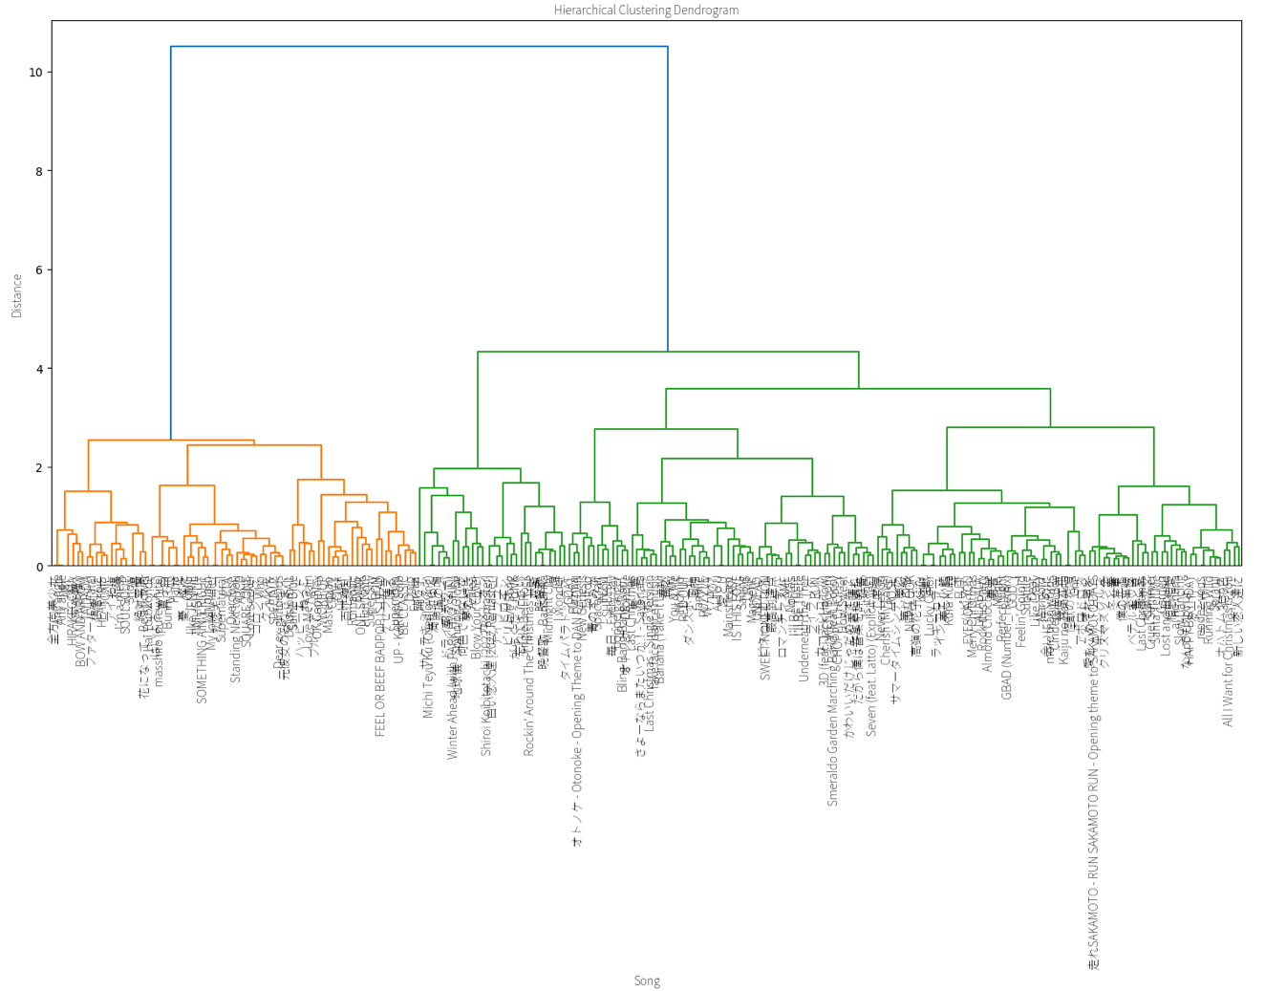

**(Fig. 14)**

* I felt that setting the distance to “2” would give me a manageable number of clusters. I did so and got 9 clusters. A new column, “cluster”, was also created to the clustering dataframe reflect the cluster each distinct song belongs to.

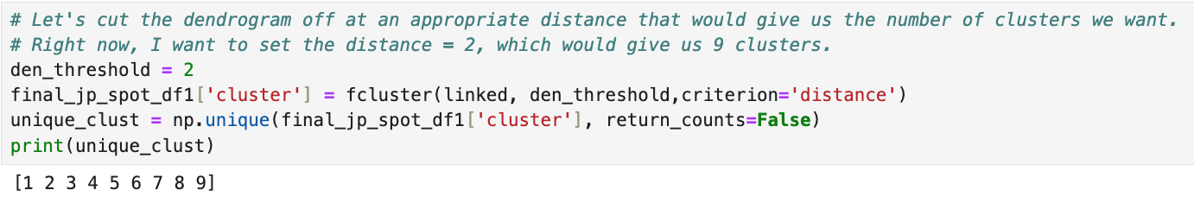

* To understand the characteristics of each cluster, I took the mean value of each musical characteristic column for each cluster (Fig. 15).

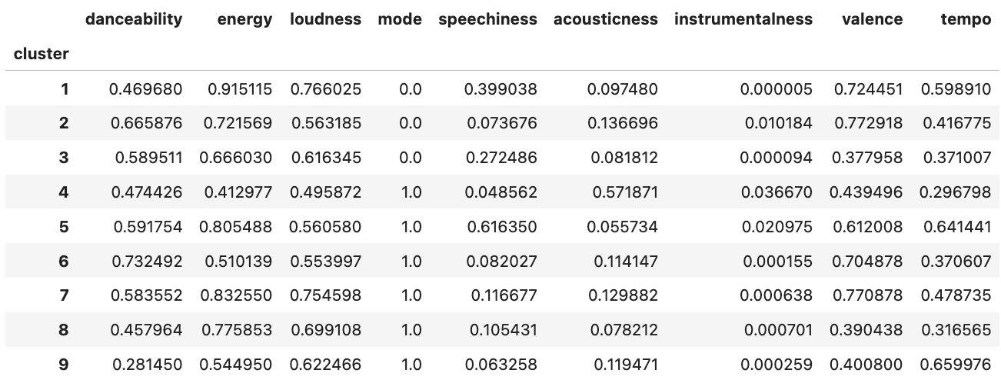

**(Fig. 15)**

* Based on these scores, I described each cluster as such:
  + Cluster #1: Intense, loud tracks with spoken elements and upbeat mood, not very danceable.
  + Cluster #2: Very upbeat, feel-good tracks suited for dancing, mostly melodic.
  + Cluster #3: Edgy or somber tracks with some speech-like elements and a synthetic sound
  + Cluster #4: Mellow, acoustic, instrumental-leaning tracks with reflective or relaxed mood.
  + Cluster #5: Energetic rap/spoken tracks with a positive tone and rhythmic drive.
  + Cluster #6: Highly danceable and happy tracks with a soft and groovy feel.
  + Cluster #7: Bright, energetic tracks with minimal spoken content and a strong rhythm
  + Cluster #8: Intense but moody or dark tracks, possibly electronic.
  + Cluster #9: Fast-paced but serious-sounding tracks that are less rhythmic and more ambient.

**Step 3: Merging “cluster” data back with the main Spotify data, getting daily cluster proportionality**

* I merged the “cluster” column back with the main Japan Spotify playlist data.
  + At this point, there are still no null values
* Finally, I grouped the dataframe by date and cluster to get a new dataframe where each row represents one day, and the values under each cluster represent the proportion songs from that cluster were included in that day’s Top 50.

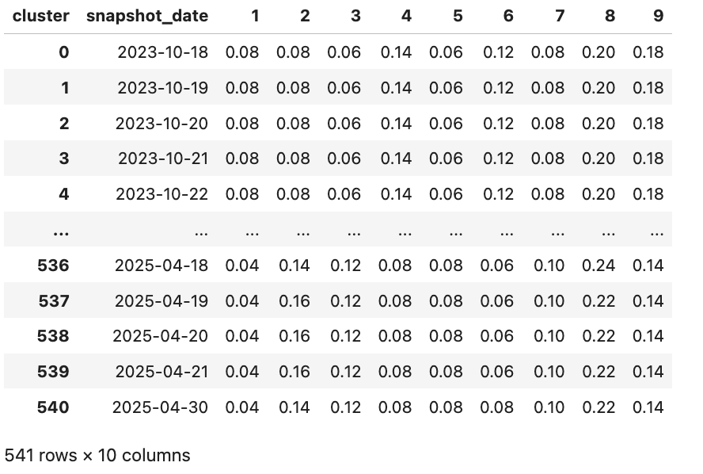

**(Fig. 16)**

This new dataframe will be combined back with the weather data in the modelling phase.

#### 3.2.2 EDA and Hierarchical Clustering on Singapore Spotify Data

* Clustering dataframe shape: 678 rows, 11 columns

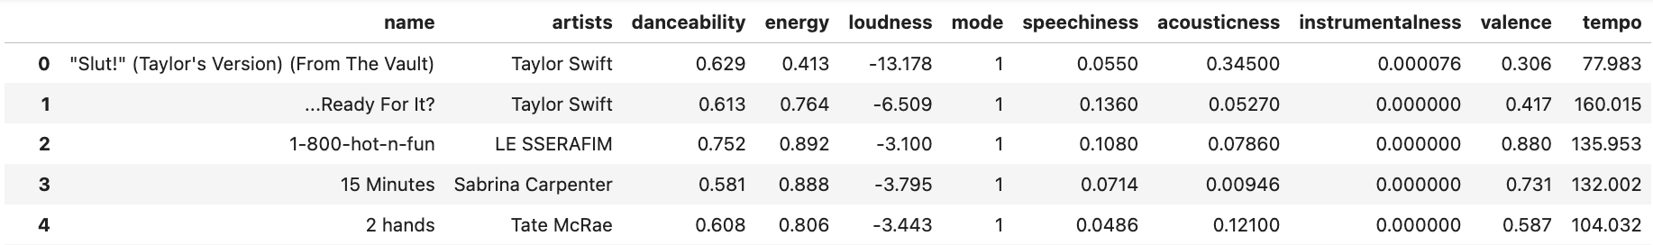

**(Fig. 17)**

* The dataframe shows us that throughout the period between 18 October 2023 and 30 April 2025, Singapore’s daily Top 50 songs on Spotify included over 600 distinct songs, which is significantly greater than those from the Japan dataset.
* This may be a reflection of Singapore’s multicultural landscape, which has several impacts:
  + The diverse mix of ethnicities (ie not merely East Asian) means that songs from a wider variety of languages can be included in the Top 50 (Malay- or Bahasa-language songs, for example)
  + The mostly English-speaking Singaporean population could mean that listeners would be open to a wider range of English-language songs
  + Being within the sphere of influence of larger Asian cultural industries (most notably from Korea, Japan, China and Taiwan) means that Singapore's daily Top 50 would also include much of the Korean and Japanese songs included in Japan's Top 50 lists.

Because of the wider variety and higher volume of distinct songs in Singapore's data, clustering is approached differently by default: setting the distance threshold at '2' returned 16 clusters, rather than Japan's 9. An early attempt to cluster Singapore's distinct songs using the same number of clusters as Japan's data reaturned clusters with less distinct musical characteristics. Thus, I shall continue with the 16 clusters returned.

**Step 2: Hierarchical Clustering**

* I then conducted hierarchical clustering and plotted the dendrogram below:

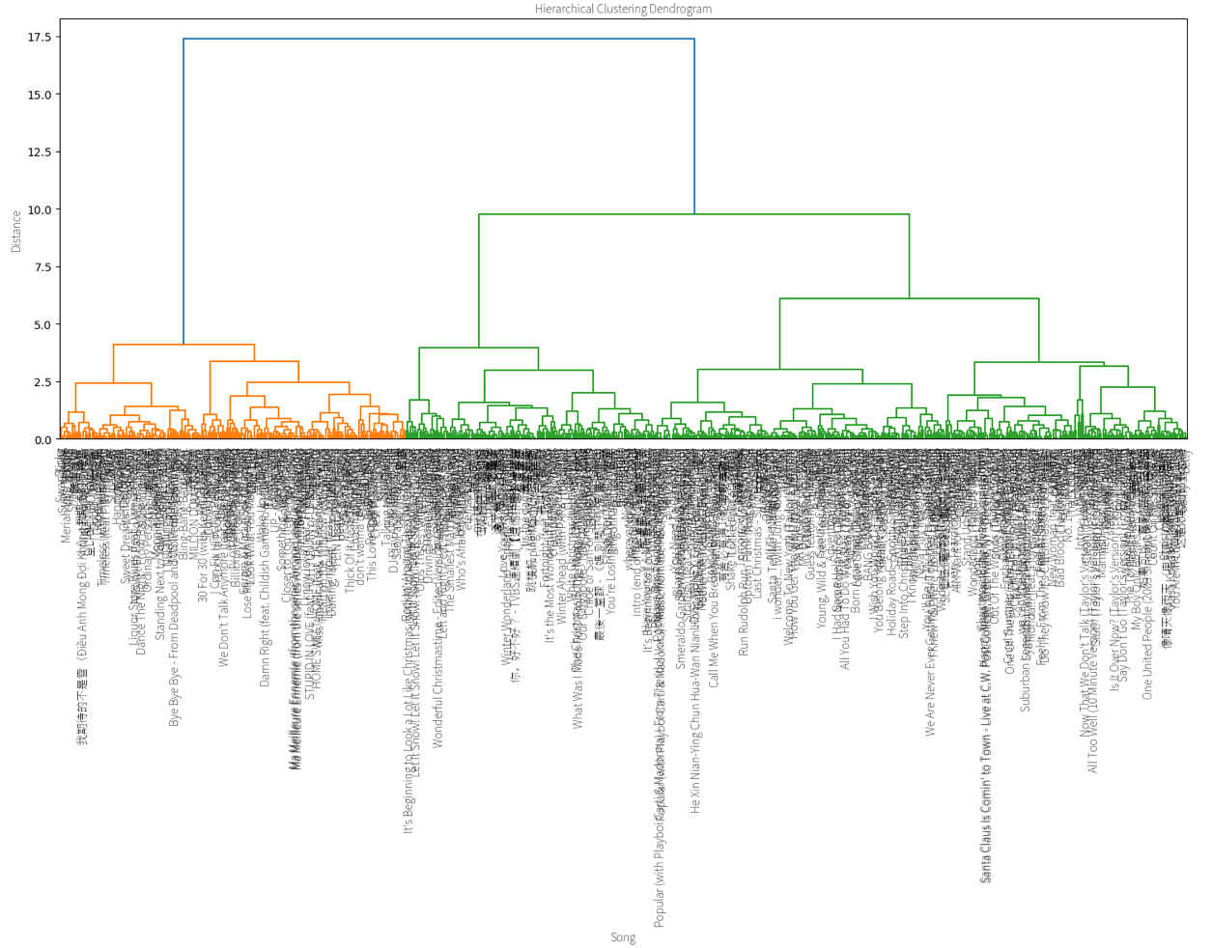

**(Fig. 18)**

* As previously mentioned, I set the distance to “2” and got 16 clusters.
* A new column, “cluster”, was also created to the clustering dataframe reflect the cluster each distinct song belongs to.

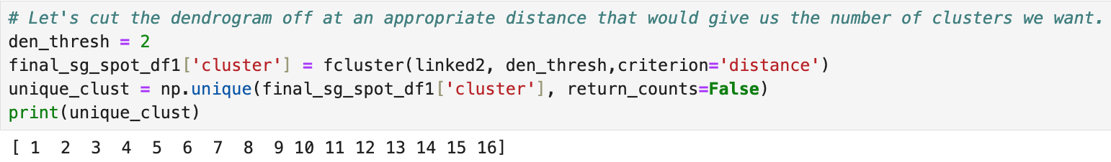

**(Fig. 19)**

* To understand the characteristics of each cluster, I took the mean value of each musical characteristic column for each cluster (Fig. 20).

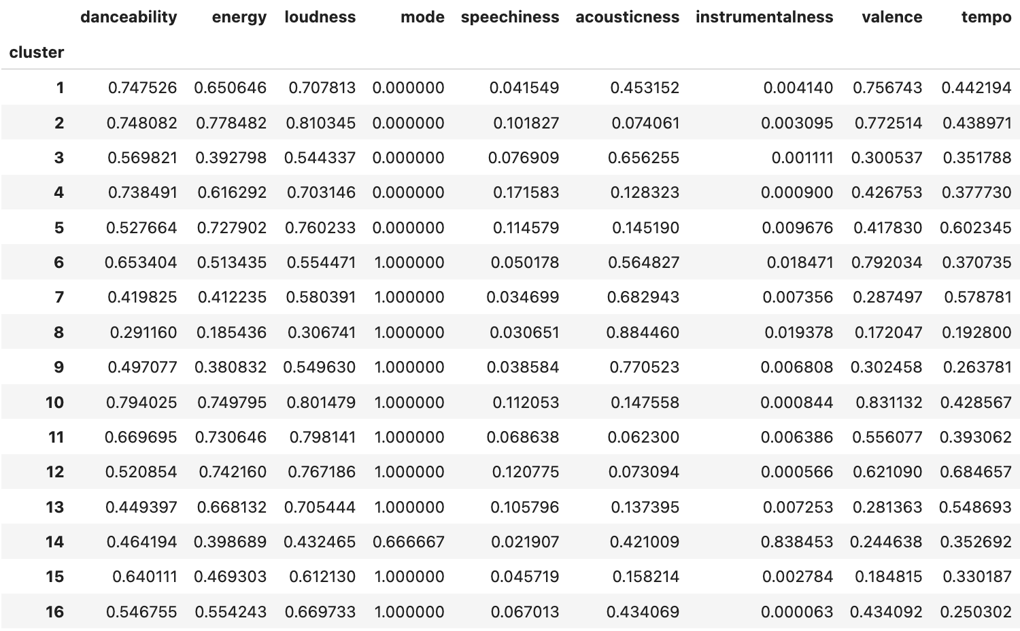

**(Fig. 20)**

* Based on these scores, I described each cluster as such:
  + Cluster 1: Upbeat Feel-Good Pop
  + Cluster 2: High-Energy Dance Songs
  + Cluster 3: Mellow Acoustic Ballads
  + Cluster 4: Vocal-Heavy Mid-Tempo
  + Cluster 5: Energetic Electronic/Rock
  + Cluster 6: Happy Major Key Pop
  + Cluster 7: Gentle Major Key Ballads
  + Cluster 8: Slow, Ambient Ballads
  + Cluster 9: Chill Acoustic Folk
  + Cluster 10: Euphoric Dance Anthems
  + Cluster 11: Energetic Major Pop/Rock
  + Cluster 12: Fast Electronic Dance
  + Cluster 13: Energetic but Moody
  + Cluster 14: Instrumental/Ambient Mix
  + Cluster 15: Sad Major Key Songs
  + Cluster 16: Mid-Tempo Acoustic Rock

**Step 3: Merging “cluster” data back with the main Spotify data, getting daily cluster proportionality**

* I merged the “cluster” column back with the main Japan Spotify playlist data.
  + At this point, there are still no null values
* Finally, I grouped the dataframe by date and cluster to get a new dataframe where each row represents one day, and the values under each cluster represent the proportion songs from that cluster were included in that day’s Top 50.

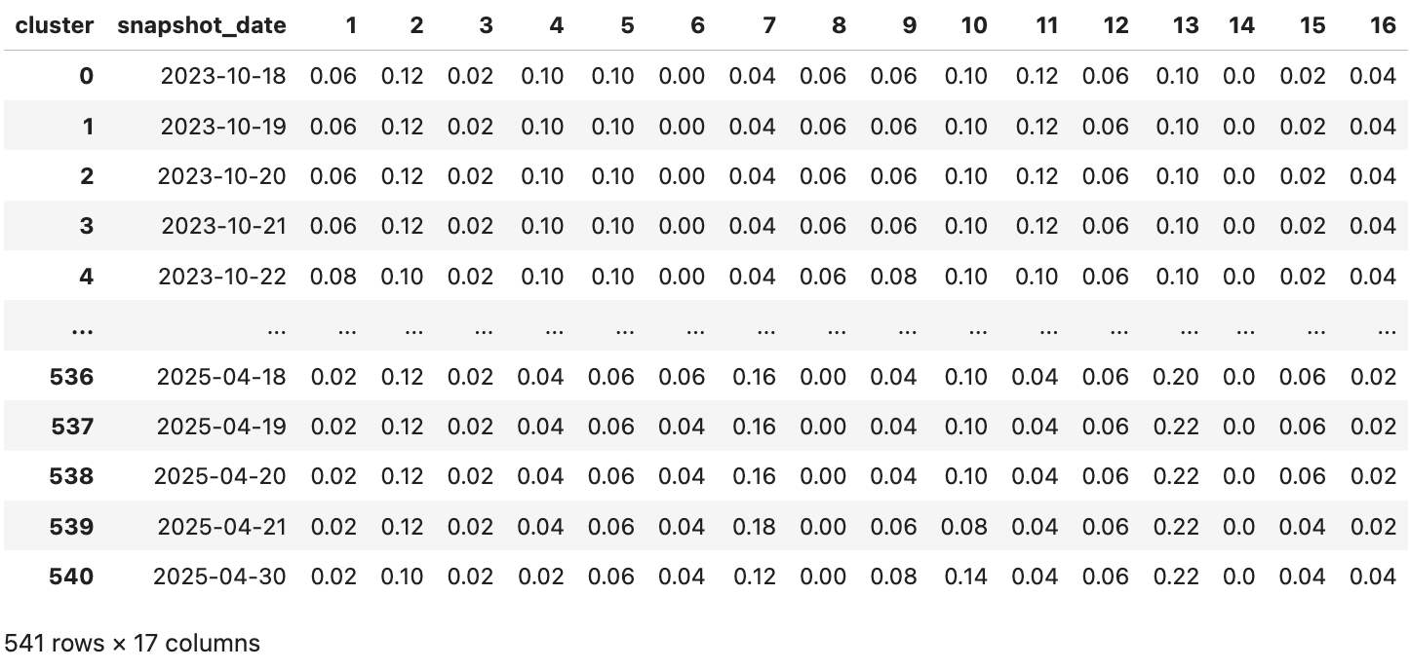

**(Fig. 21)**

This new dataframe will be combined back with the weather data in the modelling phase.

# Section 4: Modelling Preparations

### 4.1 Forming the Final Modelling Dataset (Japan)

#### 4.1.1 Merging Daily Cluster Proportionality Data with Daily Weather Data

* The Japan daily cluster proportionality dataset was merged with the Tokyo daily weather dataset.
  + Left_on = ‘snapshot_date’, right_on = ‘time’
  + After merging, the redundant ‘time’ column was dropped.

#### 4.1.2 Adding Season as a Variable to the Dataset

* The last thing I added to this combined dataset was the inclusion of seasonality as a column.
  + I ran a function which created a new “season” column in the dataset, and filled in each row’s value based on the month the ‘snapshot_date’ is in:
    - **Autumn: September to October**
    - **Winter: December to February**
    - **Spring: March to May**
    - **Summer: June to August**
* Afterward, I conducted one-hot encoding on the season column, so the seasons are converted to numerical values the model can understand.
  + Autumn was dropped, so rows with the 3 one-hot encoded columns reading “0,0,0” would refer to Autumn.

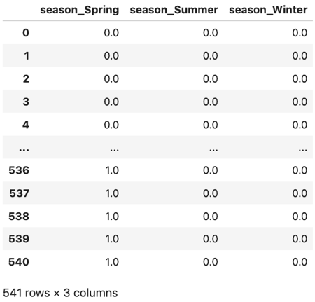

#### 4.1.3 Final Data Checks

* This final dataset does not have any null values.
* However, I noticed that the ‘sunrise (iso8601)’ and ‘sunset (iso8601)’ columns were a format potentially unreadable by the model.
  + First, I converted the columns to datetime format
  + Next, converted both columns to equal the concatenation of:
    - The hour
    - The minutes as a percentage of the hour
  + Lastly, I renamed the columns to ‘sunrise_time’ and ‘sunset_time’.
    - The data under these columns are now in float format.

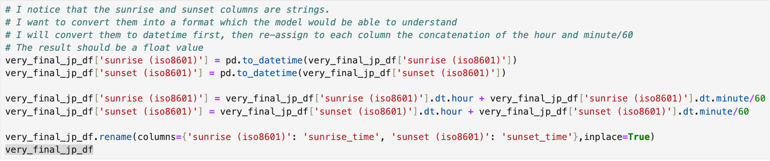

**(Fig. 22)**

**At this point, the dataset has 541 rows (representing 541 days) and 28 columns. The columns included are as follows:**

|  |  |
| --- | --- |
| **Column Name** | **Type** |
| snapshot_date | datetime64 |
| 1 | float64 |
| 2 | float64 |
| 3 | float64 |
| 4 | float64 |
| 5 | float64 |
| 6 | float64 |
| 7 | float64 |
| 8 | float64 |
| 9 | float64 |
| temperature_2m_max (°C) | float64 |
| temperature_2m_min (°C) | float64 |
| temperature_2m_mean (°C) | float64 |
| rain_sum (mm) | float64 |
| snowfall_sum (cm) | float64 |
| precipitation_sum (mm) | float64 |
| relative_humidity_2m_max (%) | int64 |
| relative_humidity_2m_min (%) | int64 |
| relative_humidity_2m_mean (%) | int64 |
| wind_speed_10m_max (km/h) | float64 |
| wind_speed_10m_min (km/h) | float64 |
| wind_speed_10m_mean (km/h) | float64 |
| daylight_duration (s) | float64 |
| sunrise_time | float64 |
| sunset_time | float64 |
| season_Spring | float64 |
| season_Summer | float64 |
| season_Winter | float64 |

### 4.2 Forming the Final Modelling Dataset (Singapore)

#### 4.2.1 Merging Daily Cluster Proportionality Data with Daily Weather Data

* The Singapore daily cluster proportionality dataset was merged with the Singapore daily weather dataset.
  + Left_on = ‘snapshot_date’, right_on = ‘date’
  + After merging, the redundant ‘date’ column was dropped.
  + ‘month’ was also dropped
  + The old index ‘Unnamed: 0’ was also dropped

Seasonality did not have to be accounted for in the data as Singapore does not have seasons.

#### 4.2.2 Final Data Checks

* ‘Snapshot_date’ needed to be converted into datetime format again.
* 1 row of data featured null values under the 16 cluster columns, for the index dated 2024-04-22, which is one of the dates that did not have Spotify data, as highlighted earlier.
  + This row was dropped.

**At this point, the dataset has 540 rows (representing 540 days) and 29 columns. The columns included are as follows:**

|  |  |
| --- | --- |
| **Column Name** | **Type** |
| snapshot_date | datetime64 |
| 1 | float64 |
| 2 | float64 |
| 3 | float64 |
| 4 | float64 |
| 5 | float64 |
| 6 | float64 |
| 7 | float64 |
| 8 | float64 |
| 9 | float64 |
| 10 | float64 |
| 11 | float64 |
| 12 | float64 |
| 13 | float64 |
| 14 | float64 |
| 15 | float64 |
| 16 | float64 |
| min_temp | float64 |
| max_temp | float64 |
| mean_temp | float64 |
| mean_rainfall | float64 |
| total_rainfall | float64 |
| max_rh | float64 |
| min_rh | float64 |
| mean_rh | float64 |
| max_ws | float64 |
| min_ws | float64 |
| mean_ws | float64 |
| mean_sunshine_hrs | float64 |

**One final note about scaling**

For both Japan and Singapore datasets, all song cluster has been normalized (i.e. scaled as a value between 0 to 1). However, all weather data has not been normalized (except the season columns in Japan’s dataset, as they are binary in nature).

This is because I intend to use XGBoost to build my model. XG Boost is based on decision trees, which are not affected by unscaled values.

# Section 5: Modelling

### 5.1 Modelling on the Japan Dataset

#### 5.1.1 Train/Test Split

* The first thing I did was create two lists of variables I wanted to assign as my X variables in two different models:

1. A list of **all weather-related columns**
2. A list of columns related only to **temperature, daylight duration and precipitation**, which were the 3 weather parameters with the clearest patterns in Tokyo’s weather dataset.

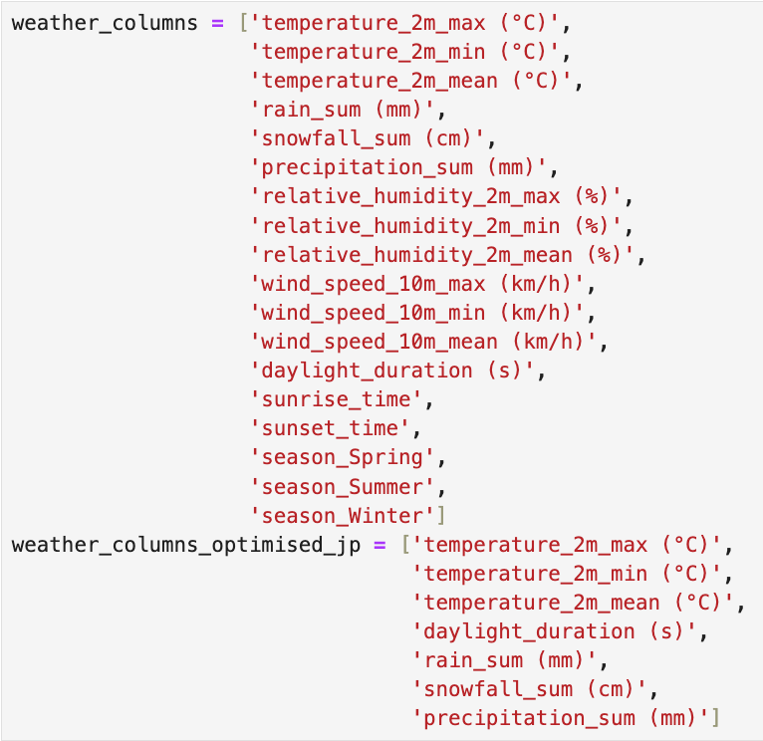

* Once again, this project aims to predict the daily proportions of each cluster based on that day’s weather conditions.
  + X = weather_columns
  + y = Only the song cluster data (1-9)
* The dataset was then split into train and split datasets:
  + X_train 🡪 80% rows under X variables
  + y_train 🡪 80% rows under y variables
  + X_test 🡪 20% rows under X variables
  + y_test 🡪 20% under y variables

#### 5.1.2 XGBoost Regression

##### 5.1.2.1 Using Train Data

From here, I followed the following sequence

1. Fit X_train and y_train into the XGBoost regressor model
   1. In order to prevent over-fitting, I set “n_estimators” to 20.

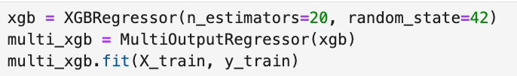

1. Predict y_train using the multi_xgb.predict() method

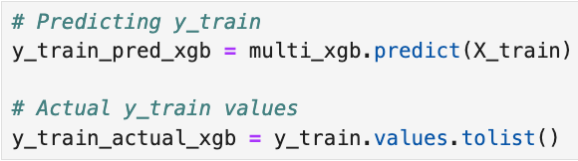

The model based on X_train and y_train returned the following results:

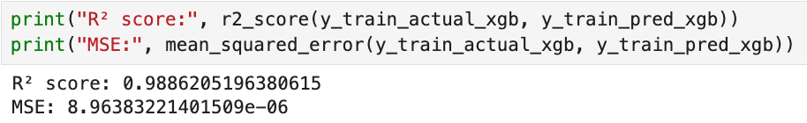

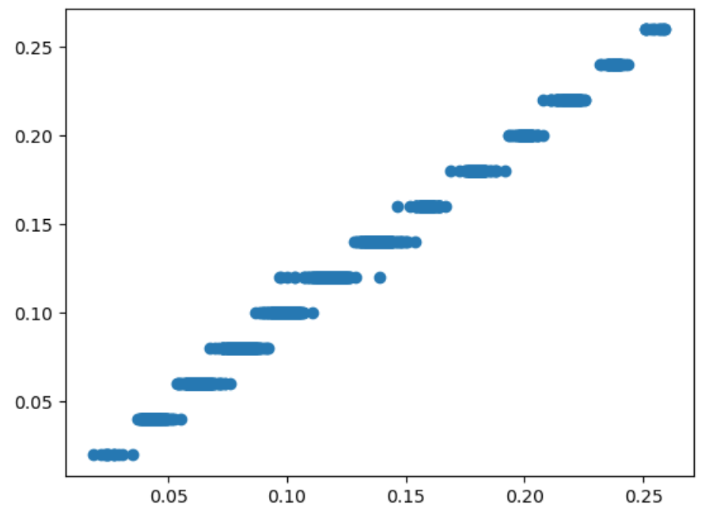

Evidently, the XGBoost model was very good at predicting y_train based on X_train.

##### 5.1.2.2 Using Test Data

Afterward, I used the model to predict y_test using X_test.

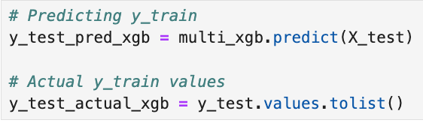

Running the test data through the model returned the following results:

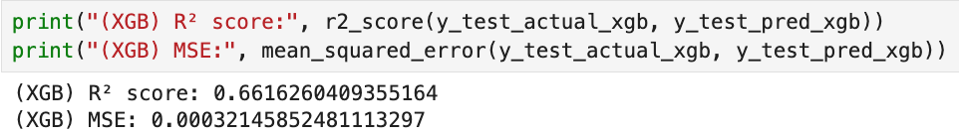

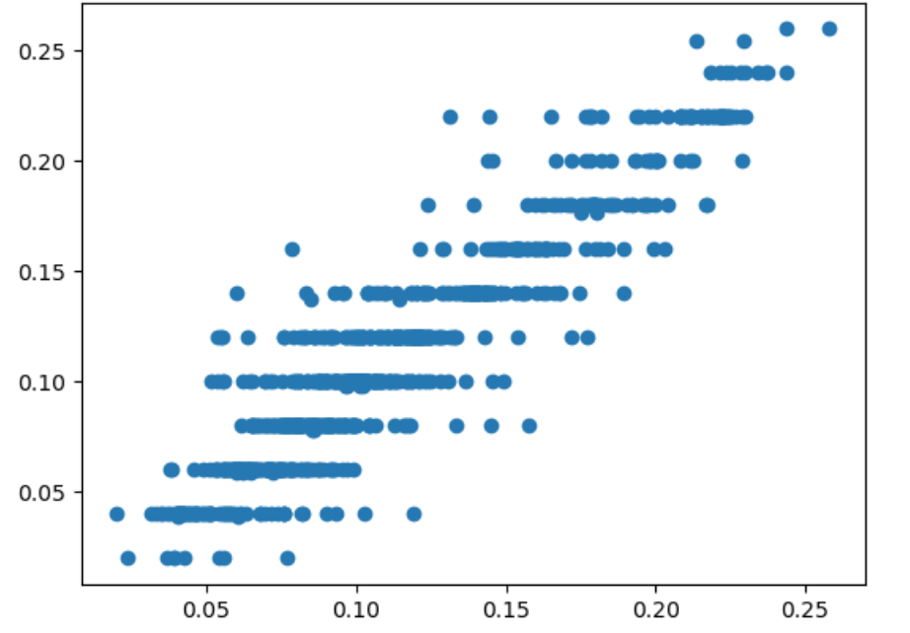

Evidently, despite n_estimators being set very low, the XGBoost model was still overfitting the data, such that the model’s performance dropped significantly when test data was run through it (from an r-squared value of 0.989 using train data to 0.662 using test data).

As the model only considers weather measurements, that the results for the test dataset were worse than those for the train dataset suggests that **weather measurements alone were unable to determine the cluster composition of Japan's Top 50 songs list**.

#### 5.1.3 Optimised Weather Data (XGBoost + Targetted X Variables)

##### Re-doing the train/test split

* This time, modelling will be done with the X variables being the list of columns related only to **temperature, daylight duration and precipitation**, which were the 3 weather parameters with the clearest patterns in Tokyo’s weather dataset.
* At this point, I re-did the train/test split with the following being assigned to X and y instead:
  + X = weather_columns_optimised_jp   
    
  + y = Only the song cluster data (1-9)
* The dataset was then split into train and split datasets:
  + X_train 🡪 80% rows under X variables
  + y_train 🡪 80% rows under y variables
  + X_test 🡪 20% rows under X variables
  + y_test 🡪 20% under y variables

##### 5.1.3.2 Using New Train Data

From here, I followed the following sequence

1. Fit X_train and y_train into the XGBoost regressor model
   1. In order to prevent over-fitting, I set “n_estimators” to 20.

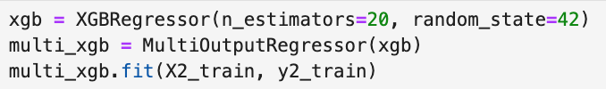

1. Predict y_train using the multi_xgb.predict() method

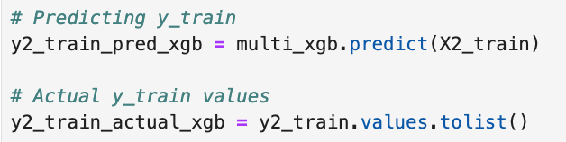

The model based on X_train and y_train returned the following results:

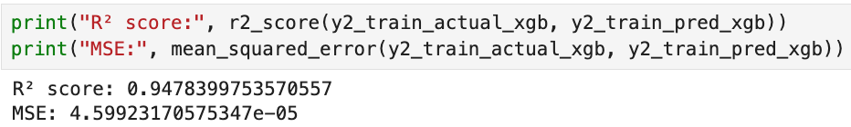

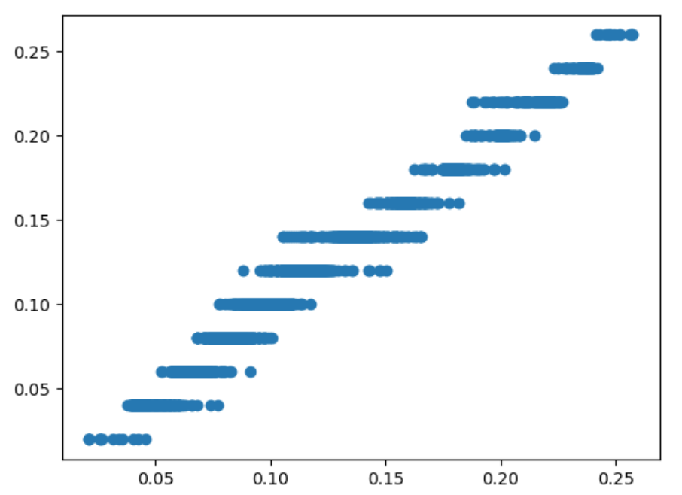

The XGBoost model was still very good at predicting y2_train based on X2_train.

##### 5.1.3.3 Using New Test Data

Afterward, I used the model to predict y_test using X_test.

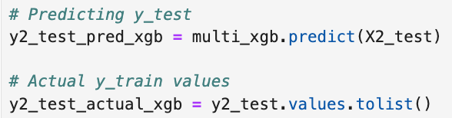

Running the test data through the model returned the following results:

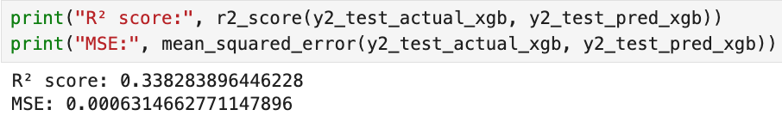

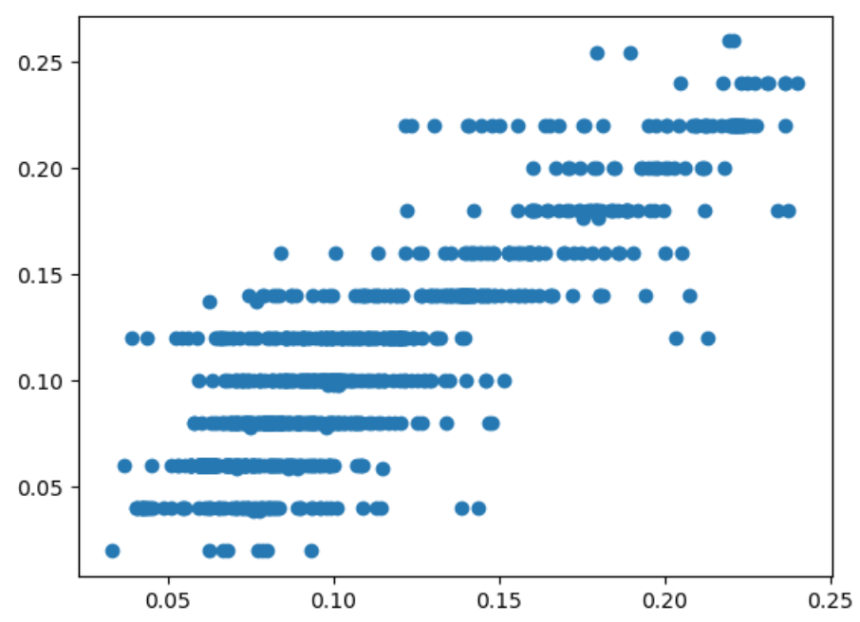

Counter to my expectations, reducing the number of X variables considered in the model only made the model perform worse when fed with test data. This serves as further evidence that weather alone is a poor determinant of the songs that make Japan’s Top 50 songs on Spotify, and that the weather ultimately does not influence users’ listening habits significantly.

#### 5.1.4 CatBoost Regression

The last thing we will do is run the data through a CatBoost regression model. It is supposed to exceed the predictive capabilities of even XGBoost regression by accounting for more complex relationships between variables.

##### 5.1.4.1 Using Train Data

1. Fit X_train and y_train into the CatBoost regressor model. We will use MultiOutputRegressor on catboost so it can account for multiple variables at once.

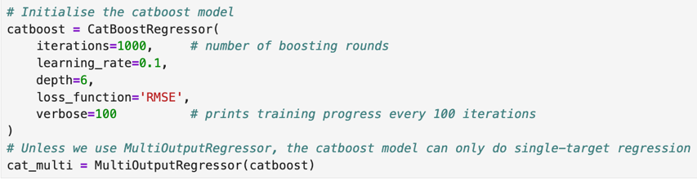



1. Predict y_train using the cat_multi.predict() method

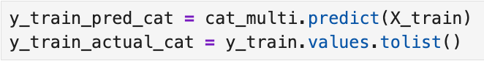

The model based on X_train and y_train returned the following results:

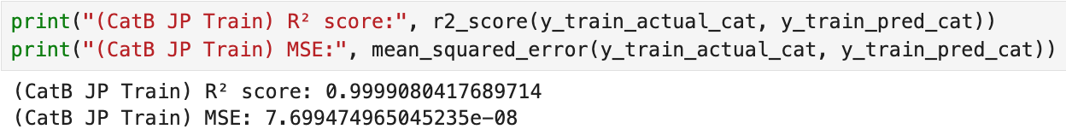

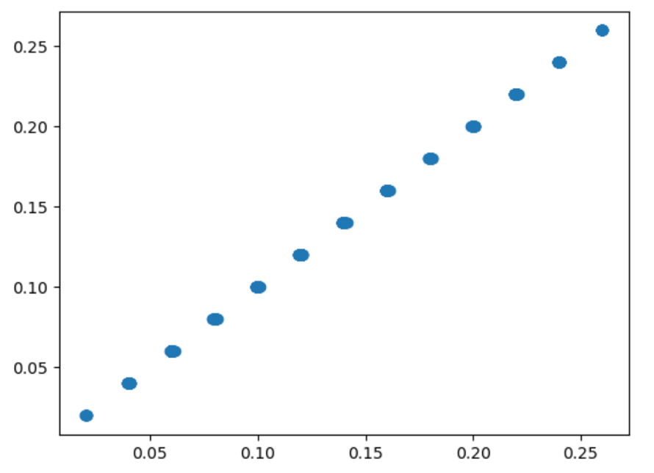

Evidently, the CatBoost model exceeded XGBoost’s accuracy in predicting y_train based on X_train.

##### 5.1.4.2 Using Test Data

Afterward, I used the model to predict y_test using X_test.

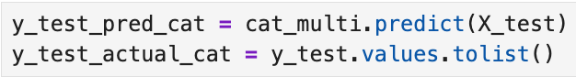

Running the test data through the model returned the following results:

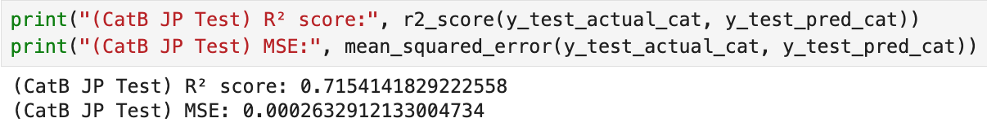

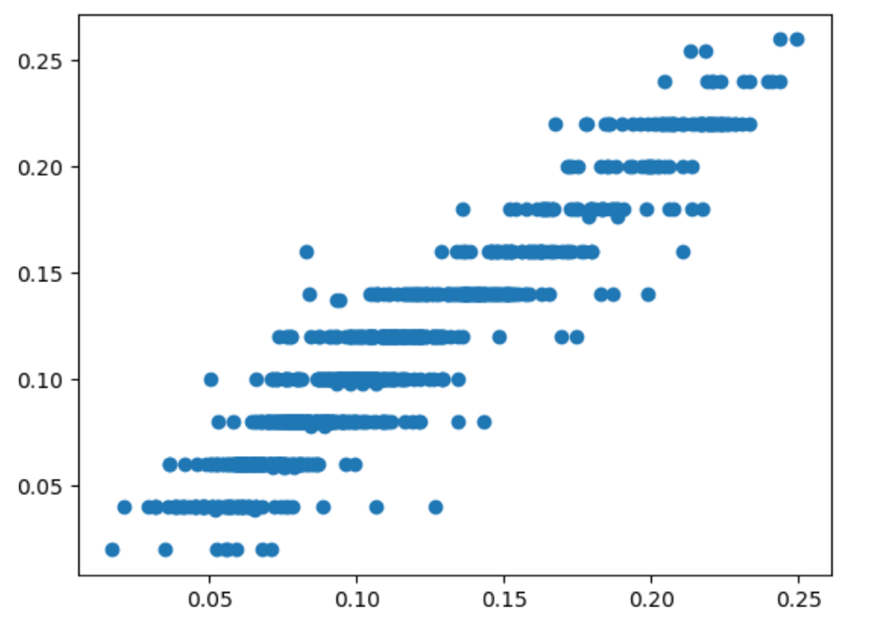

**This model is, by far, the most accurate at predicting y_test.** Nonetheless, roughly 30% of the error is still left unaccounted for by the model, which continues to signal toward the degree to which weather alone is inadequate to explain listening habits on Spotify in Japan.

### 5.2 Modelling on the Singapore Dataset

#### 5.2.1 Train/Test Split

* The first thing I did was create two lists of variables I wanted to assign as my X variables in two different models:

1. A list of **all weather-related columns**
2. A list of columns related only to **temperature, relative humidity and precipitation**, which were the 3 weather parameters with the notable patterns in Singapore’s weather dataset.

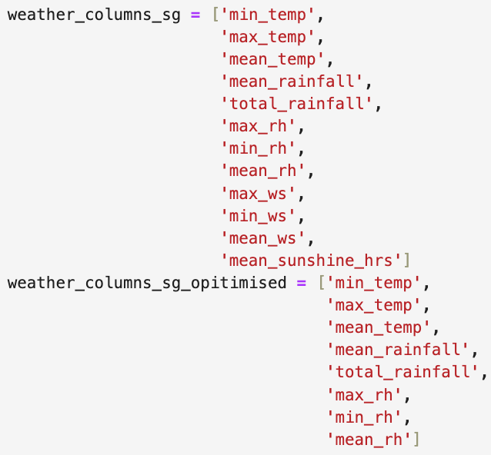

* Once again, this project aims to predict the daily proportions of each cluster based on that day’s weather conditions.
  + X = weather_columns
  + y = Only the song cluster data (1-16, as Singapore’s data has more song clusters)
* The dataset was then split into train and split datasets:
  + X_train_sg 🡪 80% rows under X variables
  + y_train_sg 🡪 80% rows under y variables
  + X_test_sg 🡪 20% rows under X variables
  + y_test_sg 🡪 20% under y variables

#### 5.2.2 XGBoost Regression

##### 5.2.2.1 Using Train Data

From here, I followed the following sequence

1. Fit X_train_sg and y_train_sg into the XGBoost regressor model
   1. In order to prevent over-fitting, I set “n_estimators” to 20.

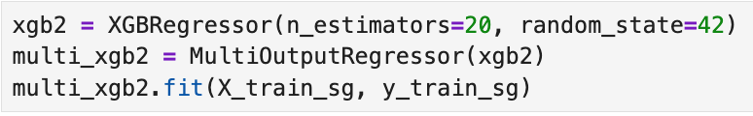

1. Predict y_train_sg using the multi_xgb.predict() method

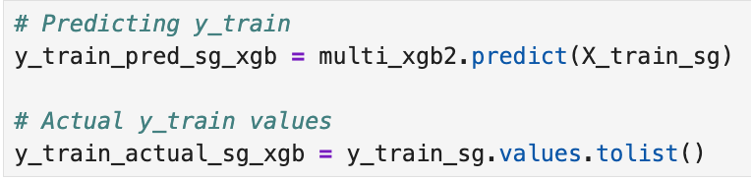

The model based on X_train_sg and y_train_sg returned the following results:

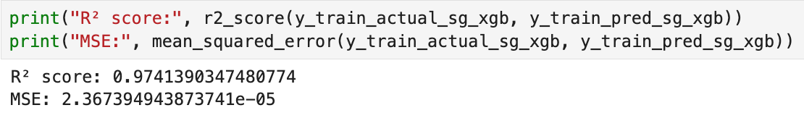

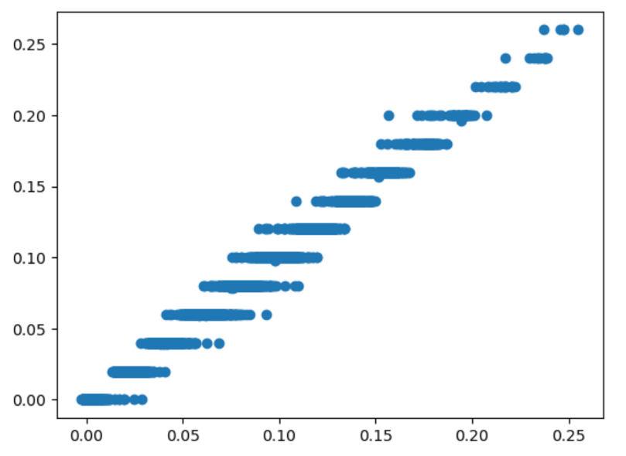

The XGBoost model was still very good at predicting y_train_sg based on X_train_sg.

##### 5.2.2.2 Using Test Data

Afterward, I used the model to predict y_test using X_test.

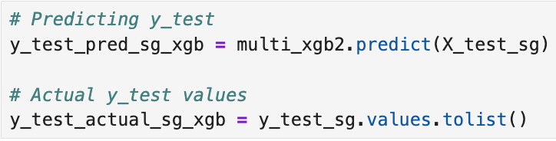

Running the test data through the model returned the following results:

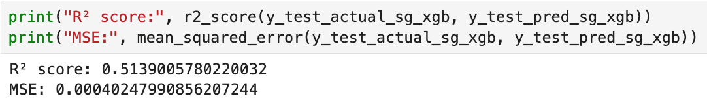

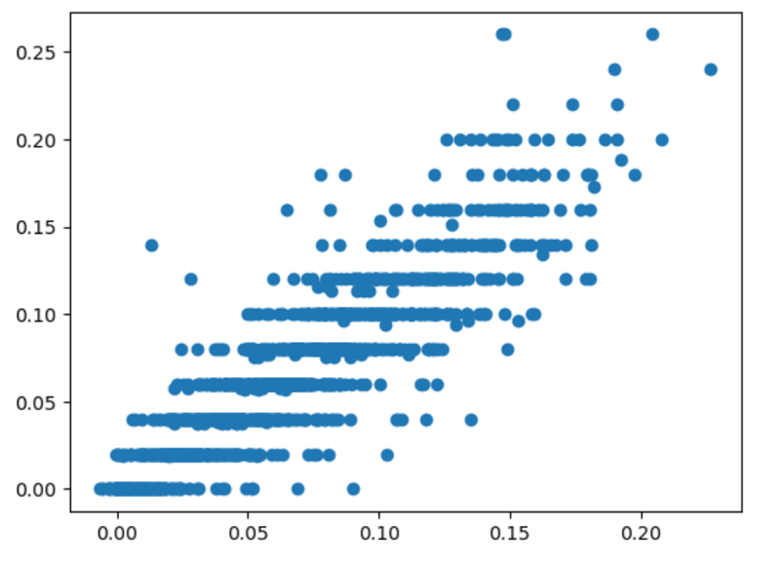

The XGBoost model was not only overfitting the Singapore data, but it also did worse than when it was fed with Singapore’s test data compared to when it was fed Japan’s test data.

#### 5.2.3 Optimised Weather Data (XGBoost + Targetted X Variables)

##### 5.2.3.1 Re-doing the train/test split

* This time, modelling will be done with the X variables being the list of columns related only to **temperature, relative humidity and precipitation**, which were the 3 weather parameters with the clearest patterns in Singapore’s weather dataset.
* At this point, I re-did the train/test split with the following being assigned to X and y instead:
  + X = weather_columns_sg_optimised   
    
  + y = Only the song cluster data (1-16)
* The dataset was then split into train and split datasets:
  + X2_train_sg 🡪 80% rows under X variables
  + y2_train_sg 🡪 80% rows under y variables
  + X2_test_sg 🡪 20% rows under X variables
  + y2_test_sg 🡪 20% under y variables

##### 5.2.3.2 Using New Train Data

From here, I followed the following sequence

1. Fit X2_train_sg and y2_train_sg into the XGBoost regressor model
   1. In order to prevent over-fitting, I set “n_estimators” to 20.

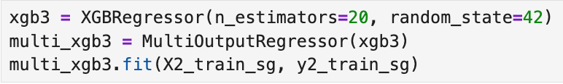

1. Predict y2_train_sg using the multi_xgb.predict() method

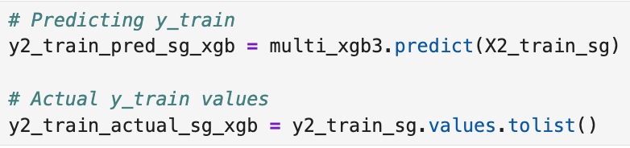

The model based on X2_train_sg and y2_train_sg returned the following results:

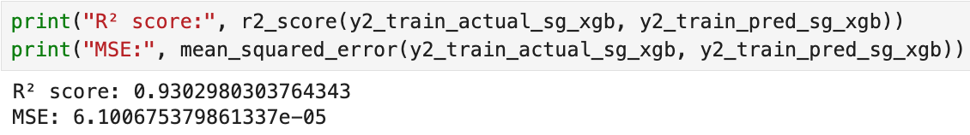

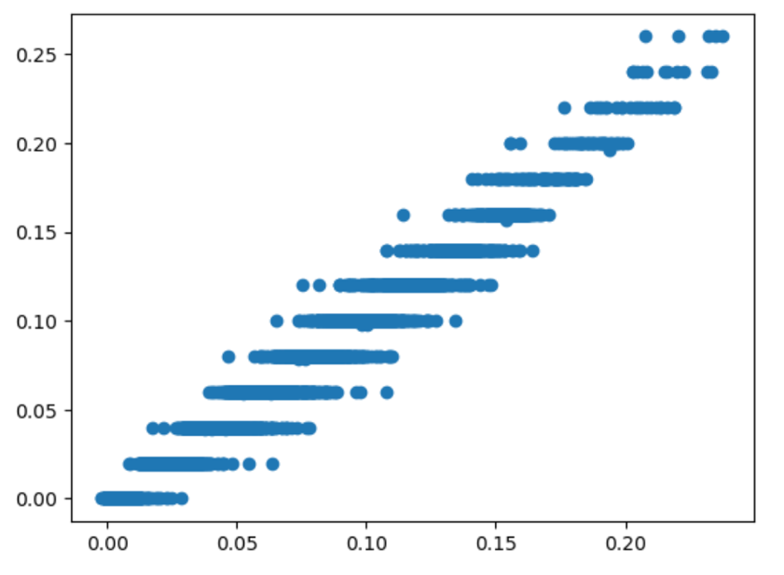

The XGBoost model was still good at predicting y2_train_sg based on X2_train_sg, but not as well as for y_train_sg and X_train_sg.

##### 5.2.3.3 Using New Test Data

Afterward, I used the model to predict y2_test_sg using X2_test_sg.

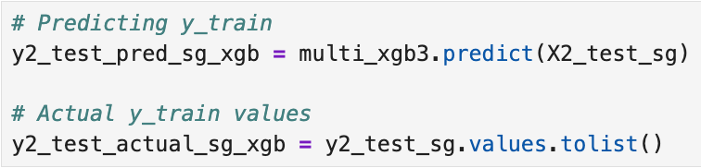

Running the test data through the model returned the following results:

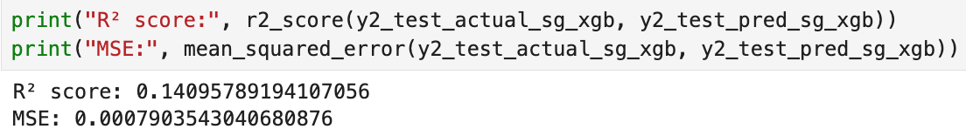

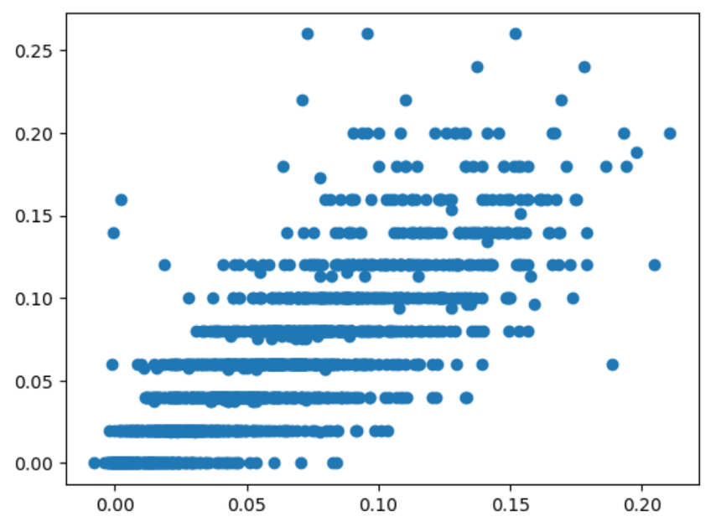

Feeding the model with Singapore’s “optimized” test data has rendered it essentially unusable to predict the proportion of each song cluster based on weather conditions.

#### 5.2.4 CatBoost Regression

Finally, we will run the Singapore data through a CatBoost regression model.

##### 5.2.4.1 Using Train Data

1. Fit X_train_sg and y_train_sg into the CatBoost regressor model. We will use MultiOutputRegressor on catboost so it can account for multiple variables at once.



1. Predict y_train using the cat_multi.predict() method

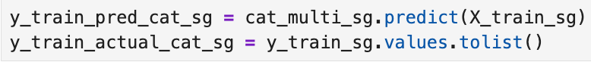

The model based on X_train and y_train returned the following results:

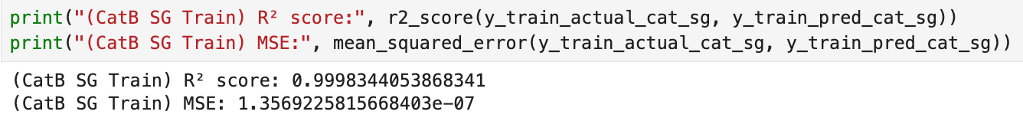

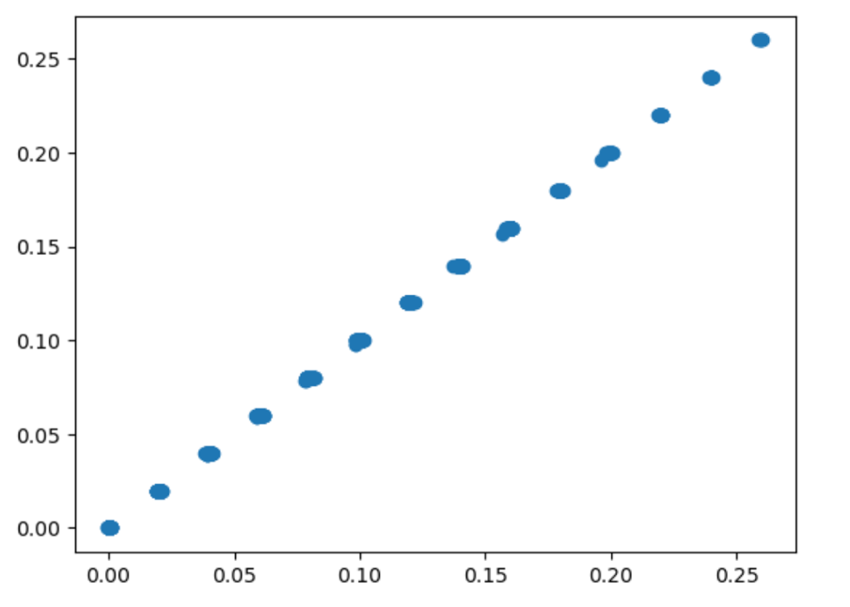

As expected, the CatBoost model exceeded XGBoost’s accuracy in predicting y_train_sg based on X_train_sg.

##### 5.2.4.2 Using Test Data

Afterward, I used the model to predict y_test using X_test.

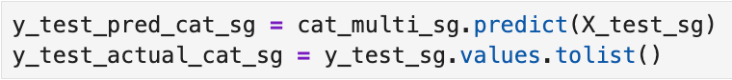

Running the test data through the model returned the following results:

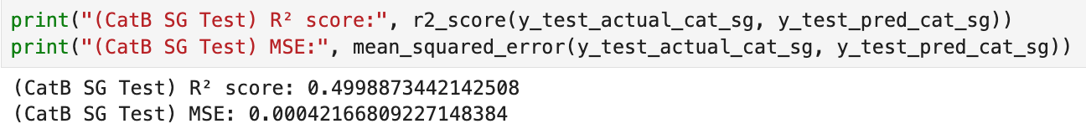

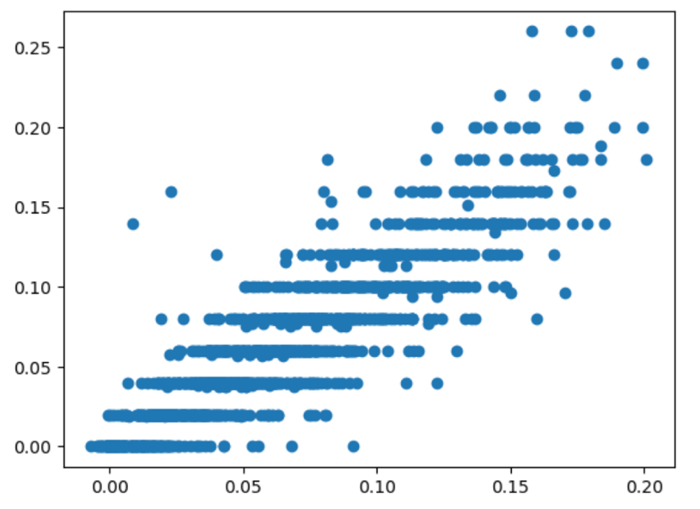

**While this model did significantly better than the “optimised** Nonetheless, roughly 30% of the error is still left unaccounted for by the model, which continues to signal toward the degree to which weather alone is inadequate to explain listening habits on Spotify in Japan.

### 5.3 Results Summary

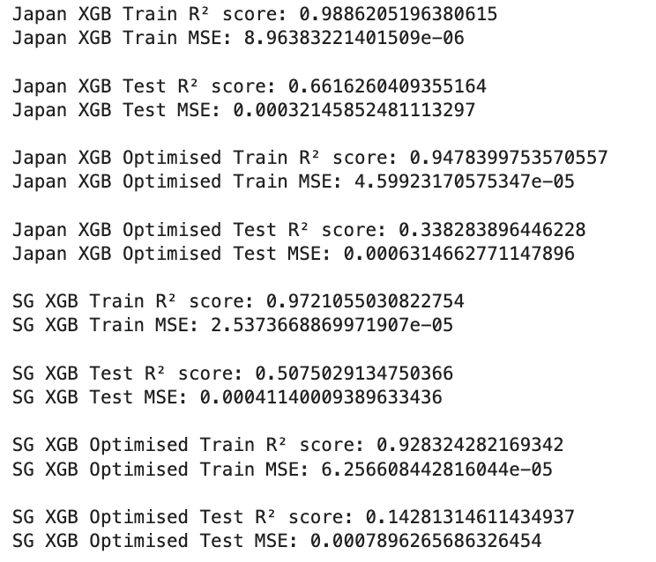

# Section 6: Conclusions & Recommendations

### 6.1 Conclusions

In both Japan's and Singapore's cases, creating a reliable model which could accurately predict the proportions of songs from prescribed clusters based on weather conditions proved difficult.

**Japan**

* When all weather data was considered, the XGBoost model ultimately faltered when fed the test data, returning an r-squared score of only 0.66.
* However, when the X variables were optimised to only include columns pertaining to temperature, daylight duration and precipitation, the model performed even worse when fed the test data, at only 0.33.
* Ultimately, the CatBoost model proved to be the best-performing of the three, returning an r-squared score of 0.71 when test data was run through it.
  + **Nonetheless, given that the model was unable to perform better than this, we can conclude that weather is not a major determinant of the mix of genres which make up Japan’s Top 50.**

**Singapore**

* When all weather data was considered, the XGBoost model ultimately faltered when fed the test data, returning an r-squared score of only 0.51, lower than the test result for Japan when all weather columns were considered.
* However, when the X variables were optimised to only include columns pertaining to temperature, daylight duration and precipitation, the model performed even worse when fed the test data, at only 0.14, making the model virtually unusable.
* Surprisingly, the CatBoost model did slightly worse than the first round of XGBoost regression, returning an r-squared score of only 0.5 when test data was run through it.
  + The inconsistency in CatBoost’s performance between Japan’s and Singapore’s cases further suggests that weather alone is a poor determinant of the music that appears on the countries’ Top 50 lists. One may even bring into question CatBoost’s superior performance in Japan’s case, as some of the inter-variable associations the model drew to make predictions might have been spurious.

**That neither model based on data from Japan nor Singapore were able to accurately predict the proportion of song clusters based on the day's weather proves that weather alone is inadequate in determining the proportion of song clusters in their daily Top 50 playlists.**

Realistically, the makeup of the Top 50 playlist is determined by a variety of factors, including:

* 1. The degree of promotion a song is receiving from the recording company that produced it
  2. The song's public reception
  3. The time of year
     1. E.g Christmas songs would experience a spike in popularity during the year-end season

### 6.2 Limitations of Project

#### 6.2.1 Inadequate Data

* To find out the correlation between weather conditions and music listening habits, **the data used for research must be specific to one geographical boundary**.
  + For modelling on Japan's data, while I could obtain data specific to Tokyo, I could not obtain Spotify data that was specific to Tokyo as well.
  + I could only fix my geography to Tokyo assuming that with it having the most Spotify users in Japan, Tokyo's listening habits would be reflective of the general Spotify data from Japan at large.

* In addition, while this whole project carried the assumption that weather conditions did affect users' listening habits to some degree, **there was no way of testing this assumption as the data does not account for more granular changes in listening habits or weather** (e.g by hour or by minute).
  + If I had this data, I can truly track the impact of weather conditions on music listening habits by observing how they change the moment the weather changes in a day.
  + This would have been especially useful for Singapore's case, where weather conditions can change sharply within the course of a day (e.g from clear and sunny skies to rainy with dark clouds)
* Lastly, **my project only accounts for one playlist, the Top 50**. Even if listening patterns are substantially influenced by the weather, the music data does not account for whether users change to a different playlist when the weather changes.
  + Spotify's platform has a wide variety of playlists that have been curated to suit different themes and moods – for example, the "Lofi Beats" playlist is noted to feature softer, slower and more gentle music which has widely been considered suitable as background music for work or study.
  + With the data I was able to obtain for this project, I was unable to track whether the listenership of a playlist like "Lofi Beats" goes up under certain weather conditions, for example, during winter season in Tokyo or rainy days in Singapore when temperatures are lower and people may want music that is "cozier" feeling.

#### 6.2.2 Data Limitations

* During the clustering phase, while I tried my best to obtain the distinct songs from Japan's or Singapore's data, **I noticed that there were still many "duplicates" in the data, in that the same song was appearing in the dataset but under either a different name, a different artist, or even different scores under the music characteristics columns**.
  + These duplicates were very difficult to remove and seeing that there would be problems with joining the 'cluster' column back to the main dataframe if I filtered out these "duplicates", I decided against removing them.
  + The data would have been slightly less noisy post-clustering if the same song only appeared under the same metadata throughout the period captured.
* I am unsure of how Spotify's algorithms come to assign scores for each song under the musical columns.
  + Some songs appeared to carry scores which I did not agree with.
    - For example, Mariah Carey’s “All I Want For Christmas Is You” has a relatively low valence of 0.336 despite it having a very upbeat and joyous mood (Fig. 23).
    - This is in comparison with a song like Wham!’s ‘Last Christmas', which has a higher valence of 0.962 (Fig. 23). This does not make sense as Carey’s song is clearly the more upbeat between the two, in terms of its subject matter, mood and musical characteristics.

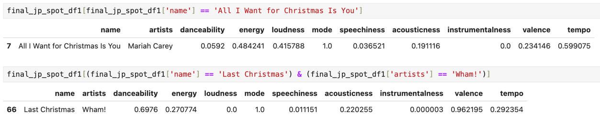

**(Fig. 23)**

#### 6.2.3 Assumptions on Music Listening Habits

* I initially intended to accurately predict the song a Spotify user in a locality would listen to based on current weather conditions. While this approach would have secured a more concrete model output, it carried the assumption that people would only listen to a specific song based on weather conditions.
  + This explains why my project involves predicting the proportionality across song clusters rather than predicting a single song at a time, to account for how users can listen to anything at any given point in time.

### 6.3 Recommendations

While this project was an imperfect attempt at building a predictive model for a local weather-based playlist on Spotify, it serves as a proof of concept.

The model can be augmented with more granular information, including minute-by-minute Spotify and weather data, for better reliability. If the relationship between music listening patterns and weather can be more robustly proven, the data aggregation and modelling processes would also have to adjust accordingly.

My model can provide a recommendation for the proportion of songs from each music style that should make up the playlist based on the day’s weather, but the songs from each cluster which do go into the playlist every day remain undetermined. Should the company be interested in developing the weather-based playlist as a platform feature, discussions must be initiated between various internal stakeholders to decide on what songs to include per day, given the complex web of considerations that go into playlist curation.

1. https://variety.com/2025/music/news/tencent-music-q4-2024-financial-results-1236340215/
2. https://www.campaignasia.com/article/asia-pacific-power-list-2025-jan-paul-jeffrey-spotify/502691